Little Mermaid Under the Sea
In Your Own Castle or at a Location of Your Choice

Little Mermaid Under the Sea Package
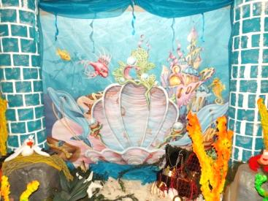
This all-out party is designed for you to decorate and host yourself by providing all the magical fairy-tale décor of Mad Hatter Par-Teas to you in your own castle while your princess and her court have a magical fairy-tale celebration they will never forget!!

Little Mermaid Under the Sea Décor:
Aqua Castle Columns with Under the Sea Backdrop
Ariel Photo Booth Backdrop
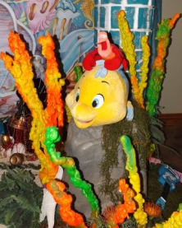
Little Mermaid Under the Sea Centerpieces
Faux Large Rocks
Large Sea Shells
Faux Aqua Foam Rocks
Faux Bright Color Sea Corals
Treasure Chest
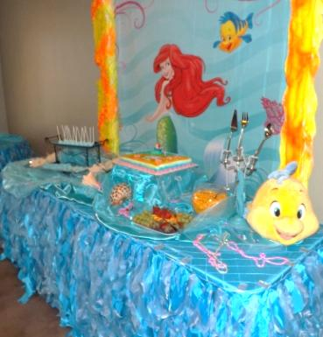
Under the Sea Décor
Little Mermaid Characters
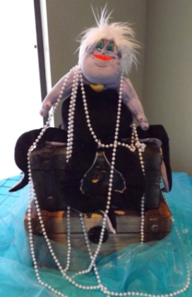
Beads, Fish Nets, Foliage, Moss, Curly Willow Branches, Tulle, and Fabric
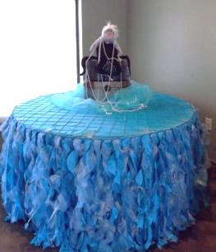
Decorated Little Mermaid Tables:
Decorated Little Mermaid Cake/Food Table
Ariel Backdrop for Food/Cake Table
Tall Faux Bright Color Sea Corals
Decorated Little Mermaid Gift Table
Little Mermaid Centerpieces
Aqua Pintuck Linens
Two Curly Willow Table Skirts
Two Treasure Chests
Aqua Buffet Platters
Beads, Curly Willow Branches, Organza, and Fabric
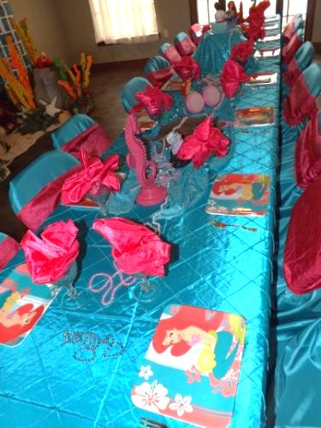
Little Mermaid Children Guest Table with Place Setting:
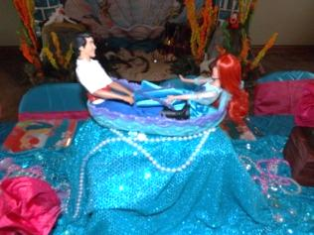
Decorated Little Mermaid Guest Table (minimum of 10 of guests)
Aqua Pintuck Linens, Beads and Sequin Fabric
Little Mermaid and Under the Sea Table Décor
Little Mermaid Characters
Aqua Chair Covers with Pink Sashes
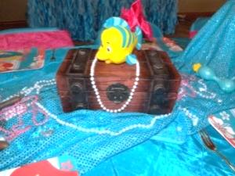
Aqua Goblets or Drinking Bowls
Little Mermaid Plates
Pink Napkin Linens
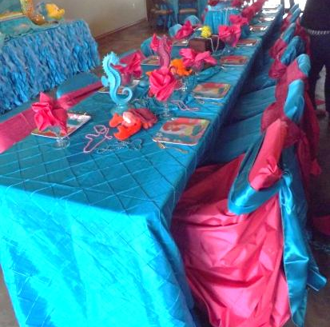
Princess Gold Forks
Aqua Punch

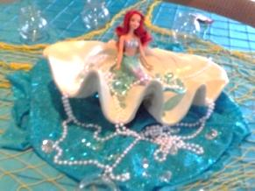
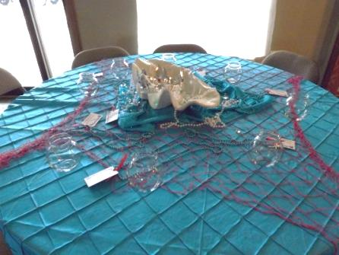
Little Mermaid Parents Guest Table:
Aqua Pintuck Linens
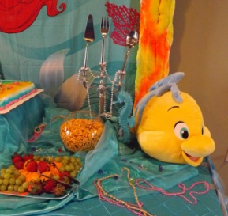
Little Mermaid Table Décor and Centerpieces
Water Bottle with Little Mermaid Labels
Mix Favored Packets

Little Mermaid Cuisine:
Aqua Buffet Platters
Star Tea Sandwiches
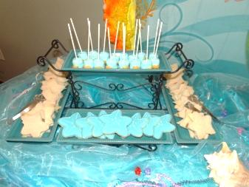
Cheese Fish Crackers
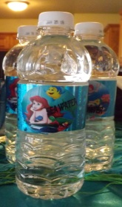
Season Fruit
Aqua Punch

Little Mermaid Desserts:
Star Fish Cookies
Marshmallow Pops

Thank You Favors from Mad Hatter Par-Teas:
Each guest will receive Bead Necklace and Princess Certificate Proclamation to mark this royal occasion!
Choose all options or customize your own design for your magical celebration from the following options:
Little Mermaid Under the Sea Decor 300
Little Mermaid Guests Table with Place Setting (up to 10 guests) 150
Decorated Little Mermaid Tables (Food/Cake and Gift) 100
Little Mermaid Cuisine 6 ea
Little Mermaid Star Cookies 30 doz
Little Mermaid Marshmallow Pops 3 ea
Decorated Little Mermaid Parents Table 25 ea
Little Mermaid Water Bottle with Mix Favored Packets 2 ea
Small Parents Sandwich Tray (serves 12 to 16 guests) 45

Additional Child Varies

Delivery and Pick-up Fee: No Delivery fee if your party location is inside Mustang School District. A Delivery fee of $35.00 will be added to the final balance if your party location is outside Mustang School District and in the Oklahoma City area. A Delivery fee of .65 cents per mile will be added to the final balance if your party location is outside Oklahoma City, Okla. Mileage will be determined via Map Quest www.mapquest.com

We are happy to answer any questions you might have and assist you in any way we can!!

Let us know if we need to reserve your date … We’d love to get started on your fairy-tale celebration!

For more information or to schedule a party
Contact: Thelma Logan (405) 641-0086 or email:
madhatterpar-teas@att.net
To see more princess photos visit us on our web site www.mad-hatter-parties.com or facebook
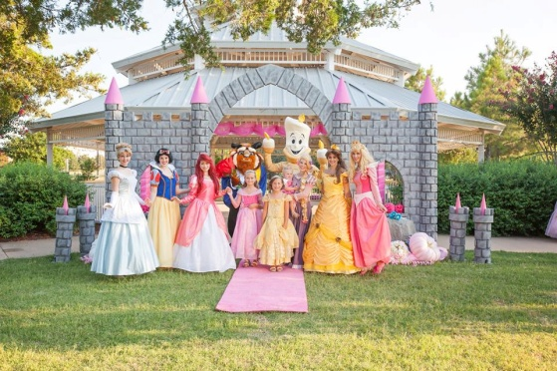
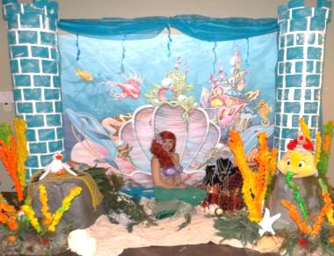
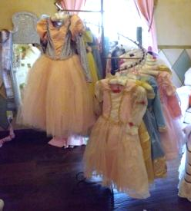
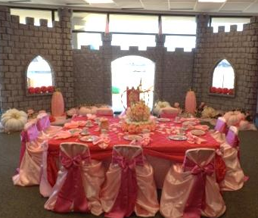
Don’t forget to check out our “Add on Party Perfections”
