C:\Users\Thelma\AppData\Local\Microsoft\Windows\Temporary Internet Files\Content.IE5\O3RKB12M\MC900022825[1].wmfC:\Users\Thelma\AppData\Local\Microsoft\Windows\Temporary Internet Files\Content.IE5\O3RKB12M\MC900022825[1].wmf **Li'l Princess Tea Social Party**

In Your Own Castle or at a Location of Your Choice

Host Your Own Princess Tea Party

Li’l Princess Tea Social Party Package up to 10 Guests

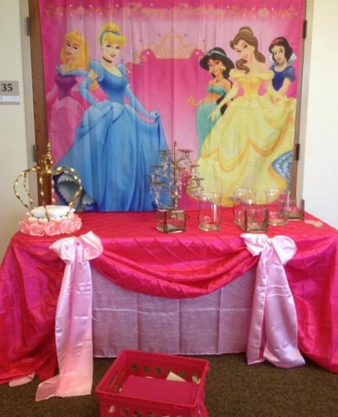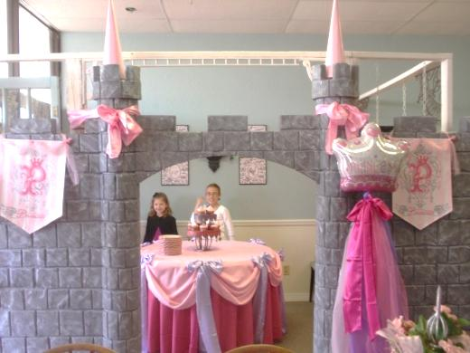This all-out party is designed for you to decorate and host yourself by providing all the magical fairy-tale décor of Mad Hatter Par-Teas to you in your own castle while your princess and her court have a magical fairy-tale celebration they will never forget!!

***Princess Décor:***

Princess Castle Backdrops 10 1/2’ wide x 8’-9 1/2’ tall

One Princess Backdrop

Princess Party Guest Table Linens & Bows

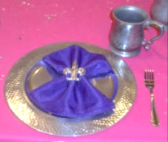Princess Cake/Food Table Linens & Bows

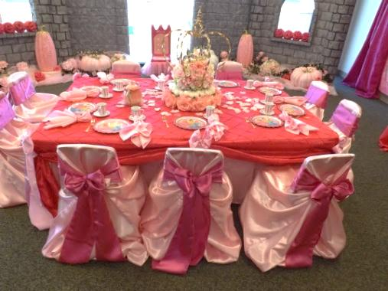Princess Theme Centerpieces

Chair Cover & Bows

Satin Bows, Organza and Tulle Fabrics

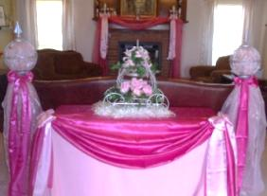*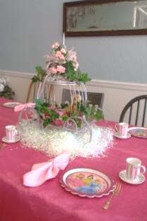****Princess and Prince Place Setting:***

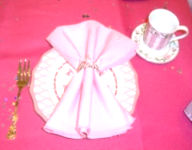Princess Child Size Tea Cups

Princess Plates

Princess Napkin Linens

Princess Napkins Rings

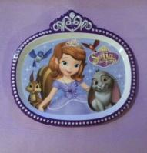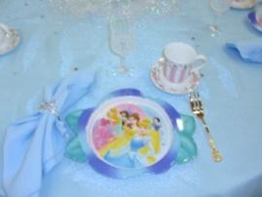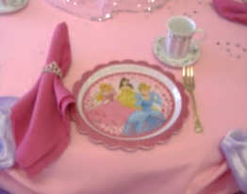Princess Forks

***Princes Activities:***

Princess Etiquette

Princess Tea (Strawberry Lemonade or Punch)

***Princess Thank You Favors:***

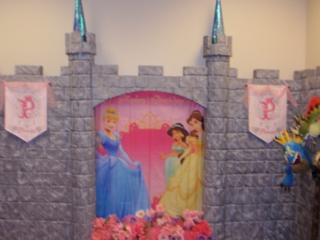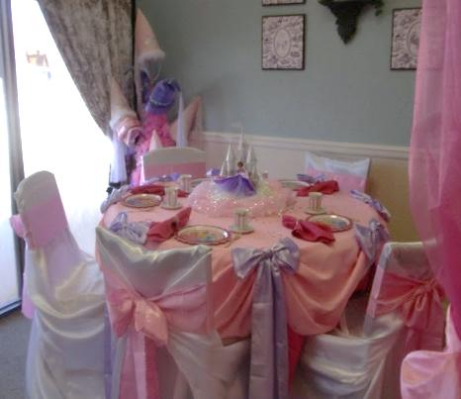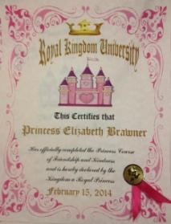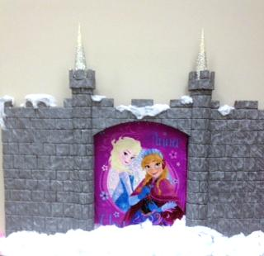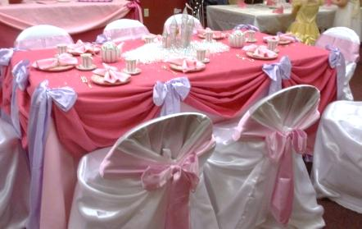Princess and her court will receive an organza favor bag at the end of the Princess Tea Party fill withbeads, Princess Etiquette and Princess Certificate Proclamation to mark this royal occasion!

Li’l Princess Tea Social Party in Your Own Castle or at a Location of Your Choice $350

Additional Child $15 ea

**Delivery and Pick-up Fee**: No Deliveryfee if your party location is inside Mustang School District. A Deliveryfee of $35.00 will be added to the final balance if your party location is outside Mustang School District and in the Oklahoma City area. A Deliveryfee of .65 cents per mile will be added to the final balance if your party location is outside Oklahoma City, Okla. Mileage will be determined via Map Quest [www.mapquest.com](http://www.mapquest.com)

We are happy to answer any questions you might have and assist you in any way we can!!

Let us know if we need to reserve your date … We’d love to get started on your fairy-tale celebration!

For more information or to schedule a party

Contact: Thelma Logan (405) 641-0086 or email: [madhatterpar-teas@att.net](mailto:madhatterpar-teas@att.net)

To see [more princess photos](http://mad-hatter-parties.com/princess-photos.php) visit us on our web site [www.mad-hatter-parties.com](http://www.mad-hatter-parties.com) or [facebook](https://www.facebook.com/pages/Mad-Hatter-Par-Teas/102454166480538)