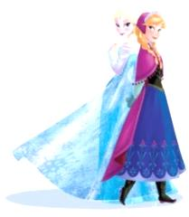
Frozen Theme Décor Options
This all-out party is designed to allow you to relax and enjoy the experience while your princess has a magical fairy-tale celebration she will never forget!!

Frozen Fairy-Tale Ice Palace Décor:
Elsa’s Ice Palace (8’ x 80”)
Two Ice Palace Columns (5’ x 12”)
Elsa’s 5’ Tall Acrylic Ice Palace Doors
Elsa’s Palace Doors Platform (18”x 6’)
White Trees
2’ Soft Olaf
Frozen Wooden Letters
Elsa’s Snowflake (4’x4’)
White Sheeting and Batting for Faux Snow
Frozen Fairy-Tale Ice Palace Décor Rental Fee 380

Frozen Fairy-Tale Guest Table Décor and Place Setting:
Aqua Table Linens
Theme Centerpieces
Artificial Manzanita Branches
Batting for Faux Snow
Aqua Chair Cover & White Sashes
Elsa Plates
Snowflake Chargers
Aqua Goblets
Napkin Linens & Forks
Elsa’s Punch
Frozen Fairy-Tale Guest Table for 10 Guests Rental Fee 150
Frozen Fairy-Tale Guest Table for 20 Guests Rental Fee 260
Frozen Fairy-Tale Guest Table for 30 Guests Rental Fee 375
Additional Guests 15 ea
Tables and Chairs Rental Varies

Queen Elsa’s Wonderland Ice Palace Décor:
Elsa’s Ice Palace (8’x80”)
Elsa’s 5’ Tall Acrylic Ice Palace Doors
Elsa’s Palace Doors Platform (18”x6’)
Elsa’s Snowflake (4’x4’)
Elsa’s Ice Palace White Columns (5’ x 12”)
Frozen 3’x4’ Acrylic Rail
7’ Acrylic Ice Palace Interior Wall
Two 9’ Ice Palace Acrylic Beaded Columns
Four 9’ Ice Palace Acrylic Beaded Curtains
Four 4’ Acrylic Ice Palace Columns
2’ Soft Olaf
White Sheeting and Batting for Faux Snow
LED Lights
Elsa’s Wonderland Ice Palace Décor Rental Fee 1080

Frozen Winter Arendelle Décor Rental
Arendelle White Castle
Icicles
6’ Tall Olaf
Ice Cubes
White Trees
Batting for Faux Snow
Frozen Winter Arendelle Décor Rental Fee 430

Frozen Winder Icy Wonderland Décor:
Crystal Garland (to hang from trees)
Snowflakes
Batting for Faux Snow
4’ Metal Snowflakes Poles
White Plastic Cubes
Frozen Winter Icy Wonderland Arendelle Décor Rental Fee 150

Frozen Winter Arendelle Guest Table Décor and Place Setting:
Child Size Tables
White or Aqua Table Linens
Frozen Theme Centerpieces
Artificial Manzanita Branches
Batting for Faux Snow
13”x13” White Ice Cubes for Seats
Clear or Elsa Plates
Snowflake Chargers
Clear or Aqua Goblets
Napkin Linens & Forks
Olaf or Elsa’s Punch
Frozen Winter Wonderland Guest Table Décor with Place Setting for 10 Guests Rental Fee 200
Frozen Winter Wonderland Guest Table Décor with Place Setting for 20 Guests Rental Fee 360
Additional Guests 15 ea

Frozen Ice Palace Décor:
Elsa’s Ice Palace (8’ x 80”)
Two Ice Palace Columns (5’ x 12”)
White Trees
2’ Soft Olaf
Frozen Letters
White Sheeting and Batting for Faux Snow
Frozen Ice Palace Décor Rental Fee 250

Frozen Aqua Castle Arch Photo Booth Décor:
Frozen Aqua Castle Arch (8’x 8’)
Backdrop
Frozen White Letters
Snowflakes
White Trees
White Ice Cubes
2’ Soft Olaf
White Sheeting and Batting for Faux Snow
Frozen Aqua Castle Arch Photo Booth Décor Rental Fee 200

Table Décor
Tables
Table Linens
Specialty Linens
Linen Overlays
Table Skirts
Food/Cake Backdrops
Food Tables
Cake/Cupcakes Tables
Candy Buffets
Gift Table
Cupcake or Cake Stand and Platters
Clear, White or Aqua Serving Platters
Raisers
Tables Décor and Tables Backdrops Décor Rental Fee Varies

Arendelle Décor:
Gray Castle Backdrops
Arendelle Flags
Banner Poles
Flag Banners
Flowers and Flowery Garland
Arendelle Summer Castle Décor Rental Fee 270

Coronation Guest Tables Décor:
Purple Table Linens
Chair Cover & Sashes
Theme Centerpieces
Coronation Plates
Clear Goblets
Napkin Linens & Forks
Elsa’s or Anna’s Punch
Coronation Guest Table plus Chair Covers and Place Setting for 10 Guests Rental Fee 150
Additional Guests 15 ea

Affordable Elegance Frozen Dress-Up Tea Party:
Princess Dress-Up At Its Finest
(Princess dress up to wear during the party)
Princess Ball Gowns
Renaissance Hats, Tiaras, or Enchanting Circlets
Princess Faux Fur Wrap/Stole
Satin Gloves
Princess Shoes
Jewels & Accessories
Aqua Table Linens
Frozen Theme Centerpieces
Batting for Faux Snow
Elsa, Coronation or Clear Plates
Clear, Aqua Goblets or White Tea Cups
Napkin Linens & Forks
Elsa’s or Anna’s Punch
Affordable Elegance Princess Dress-Up Tea Party Rental Fee (minimum of 10 guests) 30 per guests
Affordable Elegance Frozen Royal Dress-Up Tea Party Rental Fee (minimum of 10 guests) 45 per guests

Affordable Elegance Arendelle or Queen Elsa Décor:
Lil Princess Arendelle Gray Castle with Blue or White Turrets
Elsa & Anna or Elsa Backdrop for Castle Arch
Batting for Faux Snow or Flowers
Aqua, Purple or Pink Table Linens
Frozen Theme Centerpieces
Elsa’s Plates or Printed Paper Plates
Clear or Aqua Goblets
Linen Napkins & Forks
Life Size Elsa & Anna Standup
Olaf or Elsa’s Punch
Affordable Elegance Arendelle or Elsa Décor Rental Fee (minimum of 10 guests) 30 per guests

Set-up and Takedown for All-Inclusive, Signature Theme and Custom Packages:
(We need at least 3 hours before the party starts and 1 hour after it ends)
Mad Hatter Par-Teas for All-Inclusive, Signature Theme and Custom Packages Setup Fee 200 and up

Set-up and Takedown for Affordable Elegance Packages:
(You may choose the DIY option on Affordable Elegance Packages or have Mad Hatter Par-Teas setup for you.)
Mad Hatter Par-Teas for Affordable Elegance Packages Setup Fee 150 and up

Fairy-Tale Character Entertainer (My Princess Party www.myprincessparty.net):
(Your favorite fairy-tale princess will come to your very own castle to meet and greet your princess and her court.)
My Princess Party Fee 120-250

Delivery and Pick-up Fee: No Delivery fee if your party location is inside Mustang School District. A Delivery fee $35.00 will be added to the final balance if your party location is outside Mustang School District and in the Oklahoma City area. A Delivery fee of .65 cents per mile will be added to the final balance if your party location is outside Oklahoma City, Okla. Mileage will be determined via Map Quest www.mapquest.com. Additional fee may be added if a renal vehicle is needed for delivery and pickup.

Let us know if we need to reserve your date … We’d love to get started on your make-believe celebration!

For more information or to schedule a party
Contact: Thelma Logan (405) 641-0086 or email:
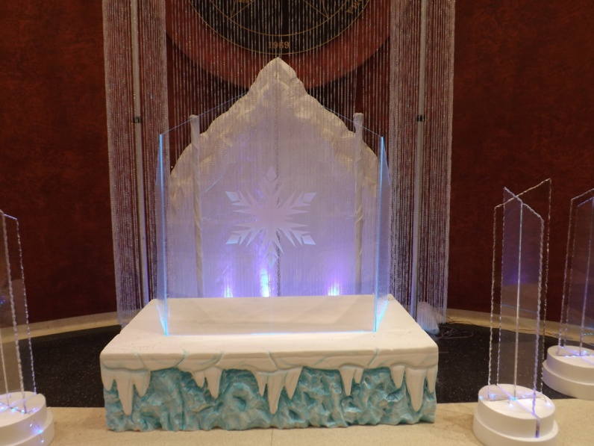
madhatterpar-teas@att.net
To see more princess photos visit us on our web site www.mad-hatter-parties.com or facebook

Don’t forget to check out our “Add on Party Perfections”

Frozen Fairy-Tale Tea Party

Frozen Fairy -Tale Tea Party
This all-out party is designed to allow you to relax and enjoy the experience while your princess has a magical fairy-tale celebration she will never forget!!

Frozen Table Décor and Place Setting Rental:
Child Size Tables
Aqua Chair Covers with White Sachs or
13”x13” White Ice Cubes for Seats
Aqua or White Table Linens
Batting for Faux Snow and Snowballs
Artificial Manzanita Branches
Frozen Theme Centerpieces
Elsa, White or Clear Plates
Snowflake Chargers
Clear, Aqua Goblets or White Tea Cups
Napkin Linens
Forks
Frozen Cuisine:
(Serves 16-20 royal court guests)
Heart Shape Tea Sandwiches
Assorted Seasonal Fruit
Carrots
Olaf Sting Cheese
Elsa or Olaf Punch (Aqua or White Punch)
Clear, White or Aqua Serving Platters
Frozen Desserts:
Clear, White or Square Aqua Translucent Serving Platters for Cupcakes or Cake
3-Tier Cupcake Stand, Princess Cupcake Stand or Cake Stand
Princess Candy Bar (assorted candy, cookies, marshmallow/cake pops
Clear, White or Aqua Serving Platters
Thank You Favors from Mad Hatter Par-Teas:
Each guest will receive thank you beads and a Princess Certificate to mark this Royal Occasion!

Set-up and Takedown for All-Inclusive, Signature Theme and Custom Packages:
(We need at least 3 hours before the party starts and 1 hour after it ends)
Mad Hatter Par-Teas for All-Inclusive, Signature Theme and Custom Packages Setup Fee 200 and up

Set-up and Takedown for Affordable Elegance Packages:
(You may choose the DIY option on Affordable Elegance Packages or have Mad Hatter Par-Teas setup for you.)
Mad Hatter Par-Teas for Affordable Elegance Packages Setup Fee 150 and up

Fairy-Tale Character Entertainer (My Princess Party www.myprincessparty.net):
(Your favorite fairy-tale princess will come to your very own castle to meet and greet your princess and her court.)
My Princess Party Fee 120-250

Delivery and Pick-up Fee: No Delivery fee if your party location is inside Mustang School District. A Delivery fee $35.00 will be added to the final balance if your party location is outside Mustang School District and in the Oklahoma City area. A Delivery fee of .65 cents per mile will be added to the final balance if your party location is outside Oklahoma City, Okla. Mileage will be determined via Map Quest www.mapquest.com. Additional fee may be added if a renal vehicle is needed for delivery and pickup.
Frozen Theme
Customize your own Magical Fairy-Tale Celebration

Customize Your Own Frozen Magical Fairy-Tale Celebration

Customize your own magical fairy-tale celebration from the following option Rentals:
Frozen Guest Table Décor and Place Setting (depending on the number of guests) .Varies
Elsa or Carnation Ceremony Place Setting 5 ea
Snow Flake Charger 2 ea
Aqua Chair Covers with White Sachs 4 ea
Elsa’s White Ice Palace Mountain 8’x80” with two 5’ Foam Columns 150
Elsa’s Ice Palace 5’ Acrylic Front Doors Décor 150
Icicle Aqua Platform for Acrylic Doors Décor 50
4’x4’ Snowflake 30
Elsa’s 3’x4’ Acrylic Frozen Railing 90
Elsa’s Ice Palace Inside 4’x7’ Acrylic Wall Panel Décor 100
9’ Ice Palace Acrylic Beaded Columns 30 ea
9’ x 12’ Ice Palace Acrylic Beaded Curtains (4’x 9’) 50 ea
4’ Acrylic Ice Palace Columns 75 ea
Snow Top Aqua Backdrop 8’x13’4” 90
6’ Olaf 150
“Do You Wanna Build a Snowman” Décor Area 50
Life Size Elsa & Anna, Krissoff, Elsa, Anna or Olaf Standup 10 ea
White Foam Ice Cubes 5 ea
White Plastic Ice Cubes 15 ea
Coronation Area .Varies
Large Arendelle Castle with Flowers 270
Small Arendelle Castle with Elsa & Anna Backdrop 150
Light Poles with Flags 20 ea
White Castle with Batting for Snow 280
Aqua Castle Arch (8’ X 9’) 100
Frozen Icy Crystal Wonderland Décor 100
Frozen or Carnation Ceremony Food/Cake Table Décor 75
Wandering Oaken’s Trading Post Décor 150
Snow Top Pine Trees 15- 30 ea
5’ Metal Knights 30 ea
Life-Size Metal Medieval Helmets (for décor not to wear) 25 ea
Candelabra and Topiaries 5 to 25 ea
Tablecloths Rental (Mid Length) 8-15 ea
Tablecloths Rental (Floor Length) 15-20 ea
Tablecloth Overlays Rental 5-10 ea
Specialty Tablecloths and Overlays Rental 30 and up ea
Specialty Table Skirt Rental 30 and up ea
Centerpiece (Small) Rental 5 ea
Centerpiece (Med) Rental 10 ea
Centerpiece (Large) Rental 20 ea
Centerpiece (X Large) Rental 30 ea
Flowers, Flower Garlands, Satin Bows, Organza and Tulle Fabrics .Varies
Princess Cupcakes (per doz) 25 and up
Frozen Cuisine with serving platters and drink containers 75
Frozen Theme Water Bottle Labels with Assorted Favor Packages .2 ea
Marshmallow/Cake pops 2 ea
Frozen Candy Buffet Bar 6 ea
Royal Dress-Up Rentals (to wear during the party) 15 to 25 ea
Frozen Favors, Thank You Gift and Keepsake Varies
Ice Princess Keepsake Costume 70 ea

Set-up and Takedown for All-Inclusive, Signature Theme and Custom Packages:
(We need at least 3 hours before the party starts and 1 hour after it ends)
Mad Hatter Par-Teas for All-Inclusive, Signature Theme and Custom Packages Setup Fee 200 and up

Set-up and Takedown for Affordable Elegance Packages:
(You may choose the DIY option on Affordable Elegance Packages or have Mad Hatter Par-Teas setup for you.)
Mad Hatter Par-Teas for Affordable Elegance Packages Setup Fee 150 and up

Fairy-Tale Character Entertainer (My Princess Party www.myprincessparty.net):
(Your favorite fairy-tale princess will come to your very own castle to meet and greet your princess and her court.)
My Princess Party Fee 120-250

Delivery and Pick-up Fee: No Delivery fee if your party location is inside Mustang School District. A Delivery fee $35.00 will be added to the final balance if your party location is outside Mustang School District and in the Oklahoma City area. A Delivery fee of .65 cents per mile will be added to the final balance if your party location is outside Oklahoma City, Okla. Mileage will be determined via Map Quest www.mapquest.com. Additional fee may be added if a renal vehicle is needed for delivery and pickup.

Let us know if we need to reserve your date … We’d love to get started on your make-believe celebration!

For more information or to schedule a party
Contact: Thelma Logan (405) 641-0086 or email:
madhatterpar-teas@att.net
To see more princess photos visit us on our web site www.mad-hatter-parties.com or facebook

