C:\Users\Thelma\AppData\Local\Microsoft\Windows\Temporary Internet Files\Content.IE5\O3RKB12M\MC900022825[1].wmfC:\Users\Thelma\AppData\Local\Microsoft\Windows\Temporary Internet Files\Content.IE5\O3RKB12M\MC900022825[1].wmf **Fairy-Tale Princess Tea Party**

In Your Own Castle or at a Location of Your Choice

Fairy-Tale Princess Tea Party (minimum of 10 guests)

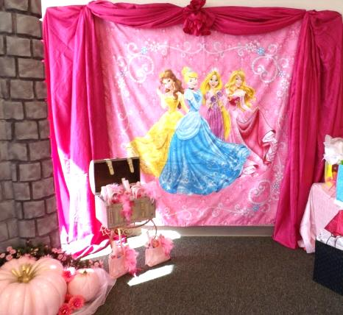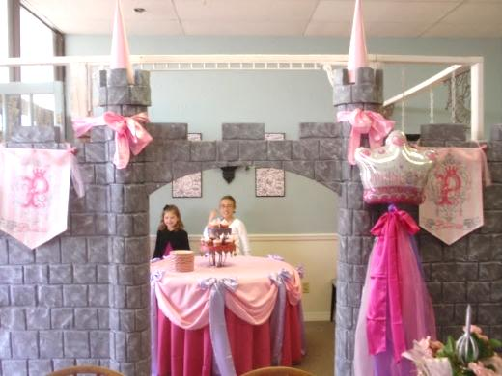This all-out party is designed for you to decorate and host yourself by providing all the magical fairy-tale décor of Mad Hatter Par-Teas to you in your own castle while your princess and her court have a magical fairy-tale celebration they will never forget!!

***Princess Décor:***

Princess Castle Backdrops 10’ wide x 8’ to 9 1/2’ tall

2 Princess Flag Banners

Princess Photo Backdrop

Princess Chair

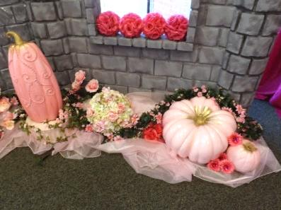Pink and White Pumpkins with Flowers

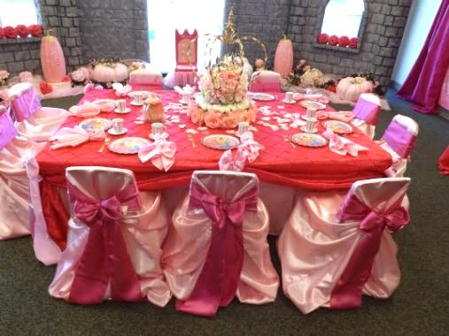Satin Bows, Organza and Tulle Fabrics

***Princess & Prince Table Décor and Place Setting:***

Princess Court Guest Table Linens & Bows

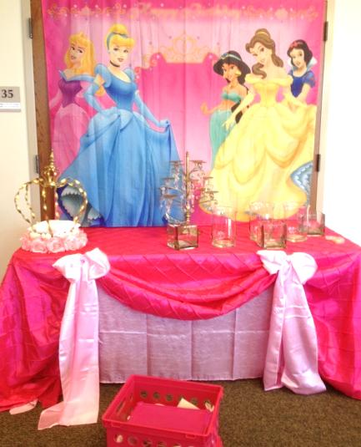Princess Centerpieces

10 - Chair Cover & Bows

10 - Princess Child Size Tea Cups or Crystal Goblets

10 - Princess Plates or Pewter Plates & Goblets

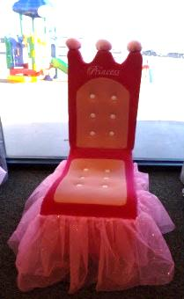10 - Princess Napkin Linens

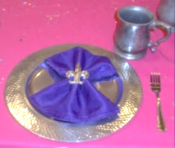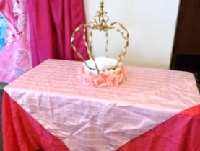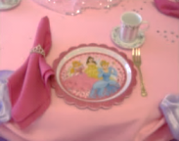10 - Tiara or Fleur de LisNapkins Rings

10 - Princess Gold Forks

Princess Teapot

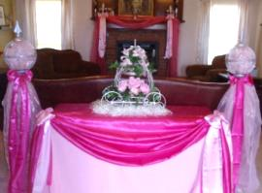***Princess Table Décor:***

Decorated Princess Cake/Food Table Linens & Bows

Decorated Princess Gift Table Linens

Princess Backdrop for Cake/Food Table

Princess Centerpieces, Princess Cupcake or Cake Stand or Princess Platters

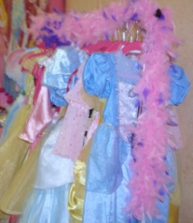***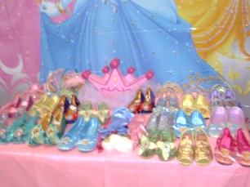Princess Dress-up at its Fines*t:** (to wear during the party)

PrincessBall Gowns

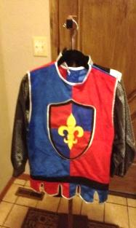Renaissance Hats, Tiaras, or **Enchanting** Circlets

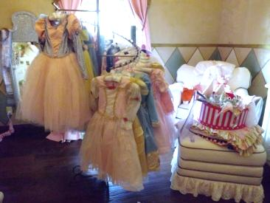Princess Faux Fur Wrap/Stole

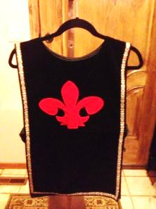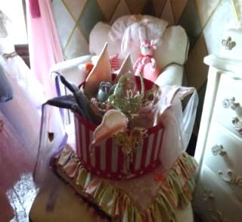Satin Gloves

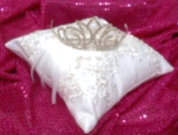PrincessShoes

Jewels & Accessories

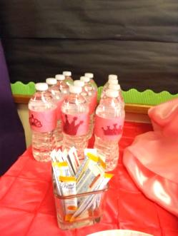Knight Costumes

***Princess Tea Cuisine:***

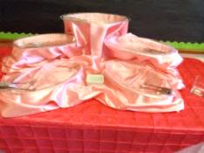(Serves 16-20 royal court guests)

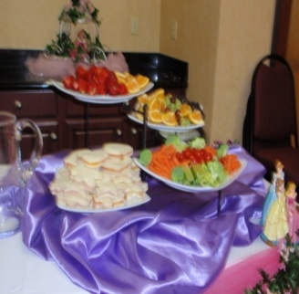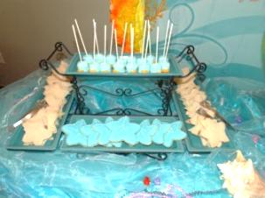Heart Shape Tea Sandwiches

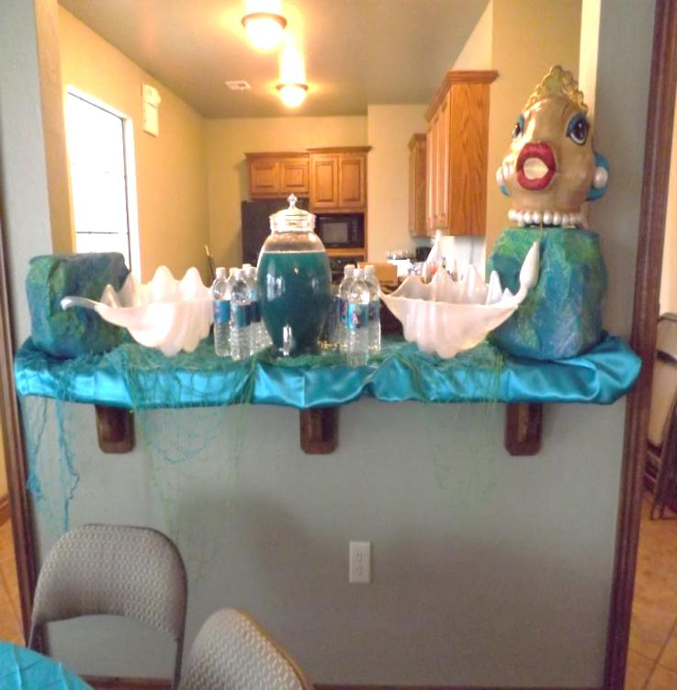Assorted Seasonal Fruit and Cheese

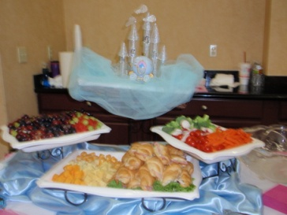Princess Tea (Strawberry Lemonade)

Princess Serving Platters

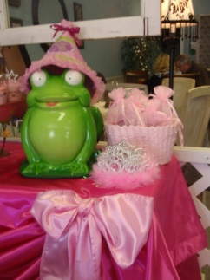***Princess Desserts:***

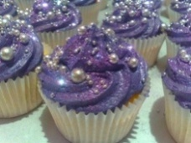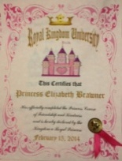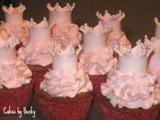Princess Cake or Cupcakes

3-Tier Cupcake Stand, PrincessCupcake Stand or Cake Stand

Princess Candy Bar (assorted candy, cookies, marshmallow/cake pops

Princess Serving Platters

***Thank You Favors from Mad Hatter Par-Teas:***

Birthday Princess will receive a special gift from Mad Hatter Par-Teas plus each guest will receive a bead necklace and Princess Certificate to mark this Royal Occasion!

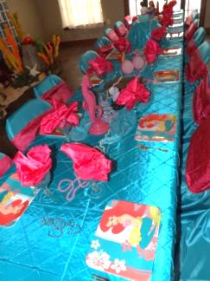***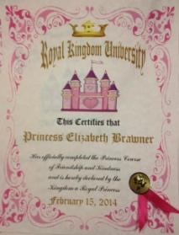****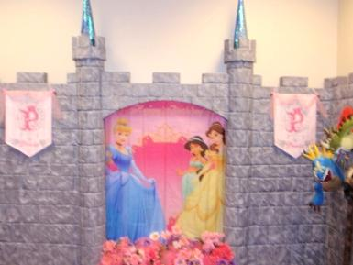*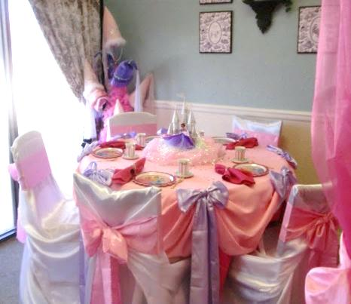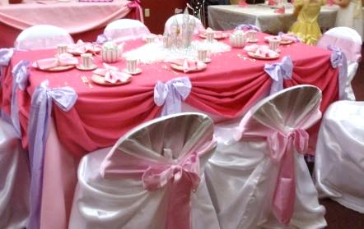

Choose all options or customize your own design for your magical celebration from the following options:

Princess Tea Party Décor (option to upgrade from princess castle to royal castle) 275

Decorated Princess Court Guests Table with Princess Place Setting for 10 145

Decorated Princess Cake/Food Table and Gift Table (option to upgrade from princess to royal) 75

Princess & Knight Dress Up for 10 (option to upgrade from princess dress up to royal dress up) 150

Princess Tea Cuisine (serves 16 to 20 court guests with option to upgrade from princess to royal) 75

Thank You Favors from Mad Hatter Par-Teas (option to upgrade) Included

Additional Child 25 ea

Additional Princess Fairy-Tale Add-on:

Princess Cupcakes (per doz) 25 and up Princess Cake .varies

Princess Candy Bar . 6 ea

Princess Water Bottle with Mix Favored Packets 2 ea

Marshmallow/Cake pops 2 ea

Princess Mini-Make Over - Each guest will also receive a mini rhinestone tiara to keep 15 ea

Princess Favors, Thank You Gift and Keepsake .varies

Mad Hatter Par-Teas Set-up and Takedown Fee 200 and up

(We need at least 3 hours before the party starts and 1 hour after it ends)

Fairy-Tale Character Entertainer Fee (My Princess Party [www.myprincessparty.net](http://www.myprincessparty.net/)) 120-250

**(Your favorite** fairy-tale **princess will come to your very own castle to tell stories or go on a magical princess hunt)**

**Delivery and Pick-up Fee**: No Deliveryfee if your party location is inside Mustang School District. A Deliveryfee of $35.00 will be added to the final balance if your party location is outside Mustang School District and in the Oklahoma City area. A Deliveryfee of .65 cents per mile will be added to the final balance if your party location is outside Oklahoma City, Okla. Mileage will be determined via Map Quest [www.mapquest.com](http://www.mapquest.com)

Don’t forget to check out our “Add on Party Perfections”

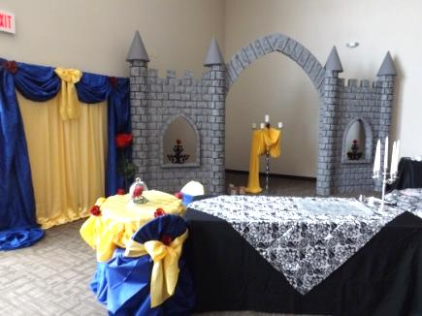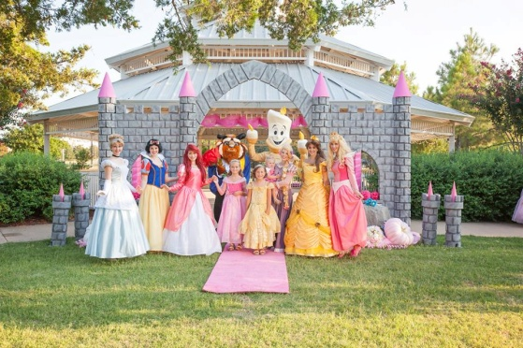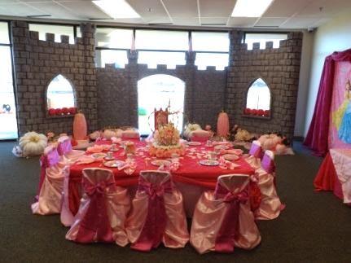

We are happy to answer any questions you might have and assist you in any way we can!!

Let us know if we need to reserve your date … We’d love to get started on your fairy-tale celebration!

For more information or to schedule a party

Contact: Thelma Logan (405) 641-0086 or email:

[madhatterpar-teas@att.net](mailto:madhatterpar-teas@att.net)

To see [more princess photos](http://mad-hatter-parties.com/princess-photos.php) visit us on our web site [www.mad-hatter-parties.com](http://www.mad-hatter-parties.com) or [facebook](https://www.facebook.com/pages/Mad-Hatter-Par-Teas/102454166480538)