**C:\Users\Thelma\AppData\Local\Microsoft\Windows\Temporary Internet Files\Content.IE5\O3RKB12M\MC900022825[1].wmfC:\Users\Thelma\AppData\Local\Microsoft\Windows\Temporary Internet Files\Content.IE5\O3RKB12M\MC900022825[1].wmf Cinderella Party Package**

In Your Own Castle or at a Location of Your Choice

Host Your Own Princess Tea Party

Cinderella Party Package (*up to 10 guests)*

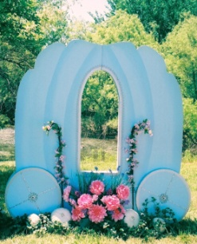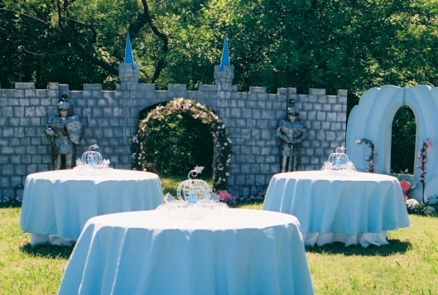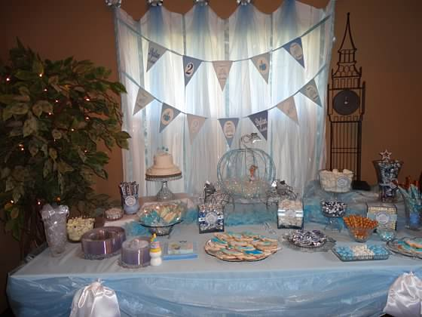 This all-out party is designed for you to decorate and host yourself by providing all the magical fairy-tale décor of Mad Hatter Par-Teas to you in your own castle while your princess and her court have a magical fairy-tale celebration they will never forget!!

**Cinderella Décor:**

Cinderella Castle Backdrop - Two Panels

6’ Blue Cinderella Carriage Prop

Cinderella Standup

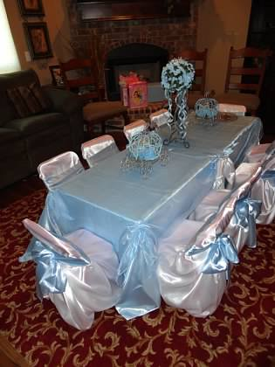Theme Centerpieces

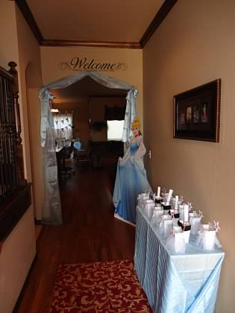Cake/Food Table Linen and Overlay

Welcome/Gift Table Linen and Overlay

Guest Table Linen and Overlay

Pumpkins, Flowers and Flower Garlands

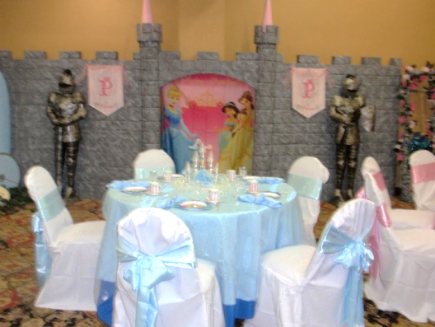Satin Bows, Organza and Tulle Fabrics

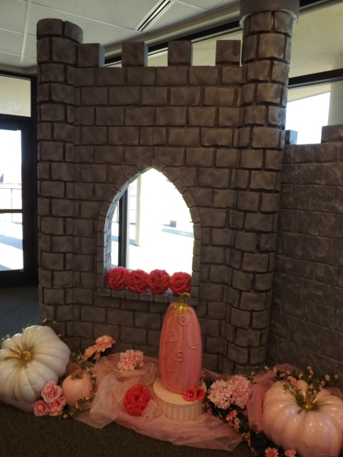

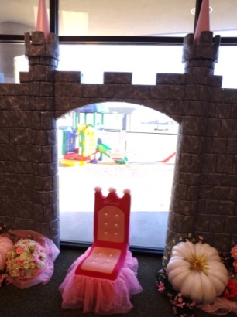***Choice of Cinderella Place Setting or Princess Dress Up***

**Cinderella Place Setting**

Tea Cups Child Size

Cinderella Plates

Napkin Linens

Tiara Napkins Rings

Princess Gold Forks

10 - White Chair Cover & Blue Bows

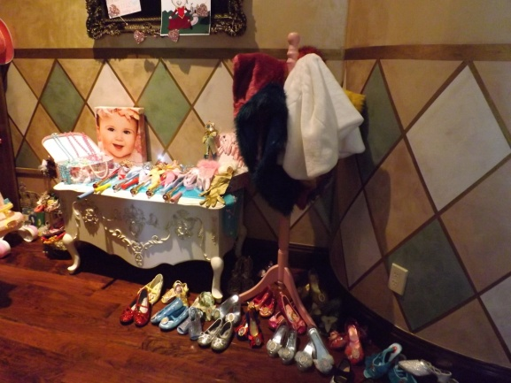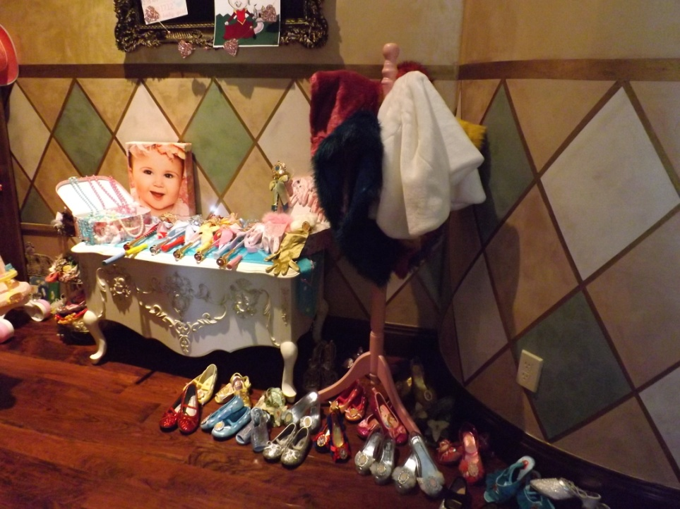

**Princess Dress Up**

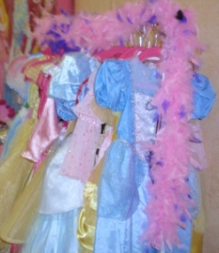(To wear during the party)

Princess BallGowns

Princess Hats or Tiaras

Princess Faux Fur Stole

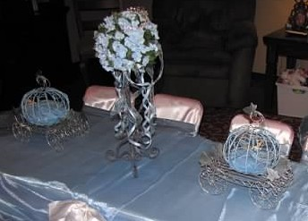Satin Gloves

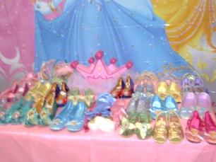PrincessShoes

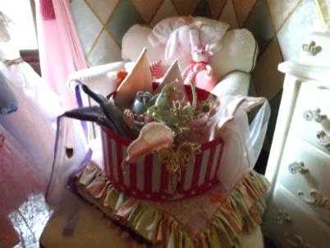Jewels & Accessories

Cinderella Party in Your Own Castle or at a Location of Your Choice $375

Additional Child $25 ea

Don’t forget to check out our “Add on Party Perfections”

**Delivery and Pick-up Fee**: No Deliveryfee if your party location is inside Mustang School District. A Deliveryfee of $35.00 will be added to the final balance if your party location is outside Mustang School District and in the Oklahoma City area. A Deliveryfee of .65 cents per mile will be added to the final balance if your party location is outside Oklahoma City, Okla. Mileage will be determined via Map Quest [www.mapquest.com](http://www.mapquest.com)

We are happy to answer any questions you might have and assist you in any way we can!!

Let us know if we need to reserve your date … We’d love to get started on your fairy-tale celebration!

For more information or to schedule a party

Contact: Thelma Logan (405) 641-0086 or email:

[madhatterpar-teas@att.net](mailto:madhatterpar-teas@att.net)

To see [more princess photos](http://mad-hatter-parties.com/princess-photos.php) visit us on our web site [www.mad-hatter-parties.com](http://www.mad-hatter-parties.com) or [facebook](https://www.facebook.com/pages/Mad-Hatter-Par-Teas/102454166480538)