C:\Users\Thelma\AppData\Local\Microsoft\Windows\Temporary Internet Files\Content.IE5\O3RKB12M\MC900022825[1].wmfC:\Users\Thelma\AppData\Local\Microsoft\Windows\Temporary Internet Files\Content.IE5\O3RKB12M\MC900022825[1].wmf **Affordable Elegance**

Princess Tea Party

Princess Tea Party (minimum of 10 guests)

***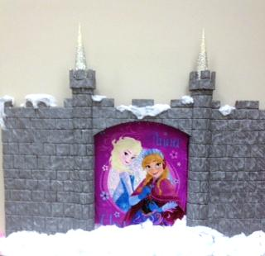****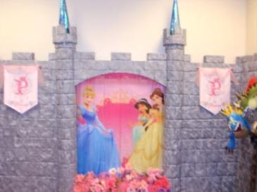*This all-out party is designed for you to decorate and host yourself by providing all the magical fairy-tale décor of Mad Hatter Par-Teas to you in your own castle while your princess and her court have a magical fairy-tale celebration they will never forget!!

***Princess Décor:***

Princess Castle Backdrops 10’ wide x 8’ to 9 1/2’ tall

One Princess Backdrop

Princess Party Guest Table Linens

Linen Overlay

Satin Bows

Princess Centerpiece

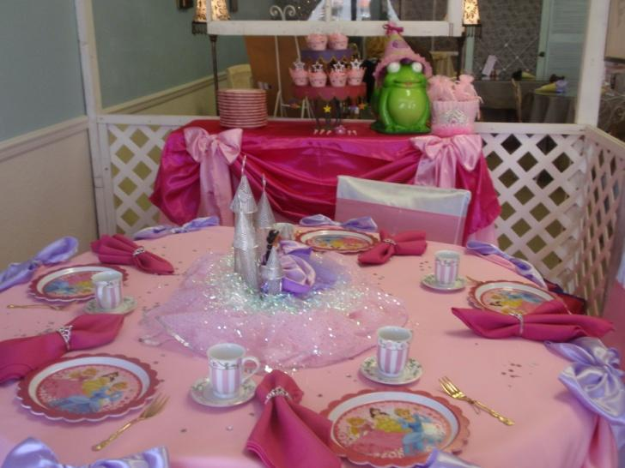Organza and Tulle Fabrics

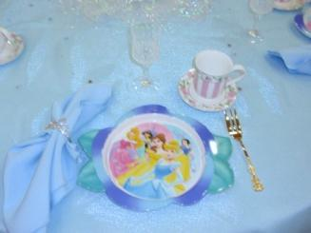**Princess Tea Party Setting**

Princess Plates

Child Size Tea Cups or Goblets

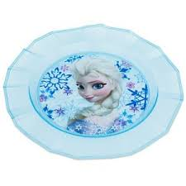Princess Napkins Rings

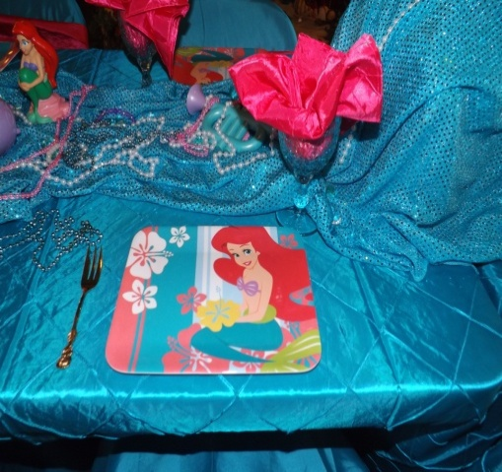Princess Forks

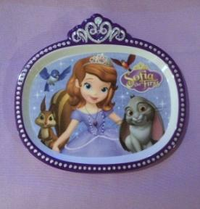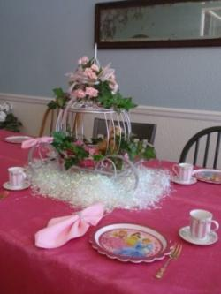Linen Napkins

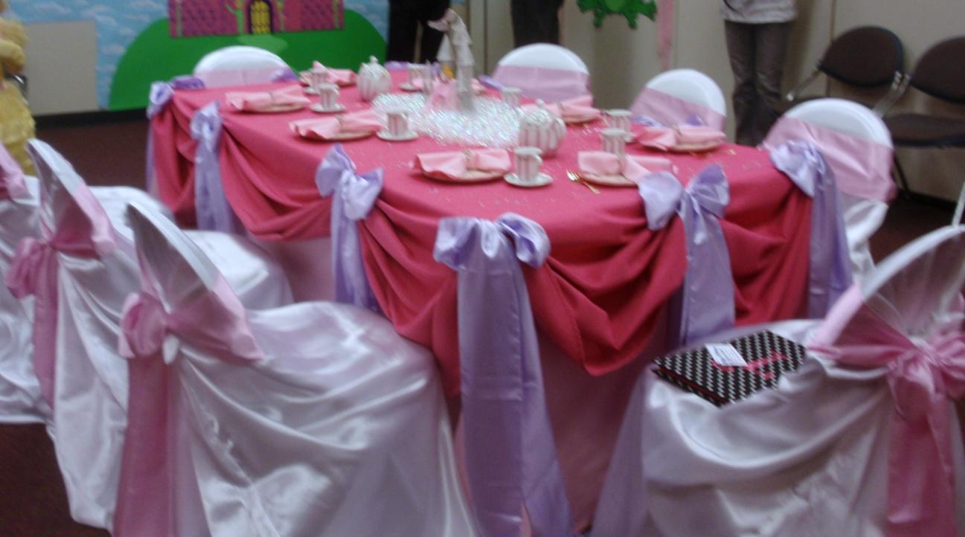**Princess Tea Activity**

Princess Etiquette

Princess Tea (Strawberry Lemonade or Punch)

**Princess Tea Party Thank You Favors**

Princess and her court will receive Bead Necklaces.

**All Affordable Elegance Princess Tea Packages are $30 per Guests (minimum of 10 guests)**

**Delivery and Pick-up Fee**: No Deliveryfee if your party location is inside Mustang School District. A Deliveryfee of $35.00 will be added to the final balance if your party location is outside Mustang School District and in the Oklahoma City area. A Deliveryfee of .65 cents per mile will be added to the final balance if your party location is outside Oklahoma City, Okla. Mileage will be determined via Map Quest [www.mapquest.com](http://www.mapquest.com)

Don’t forget to check out our “Add on Party Perfections”

* **Make your Princess Tea Party more exciting by adding our Princess Dress-Up Fashion Show between $5 to $25 per guests**
* **Make it even more special by adding Chair Covers & Bows for $4 ea**

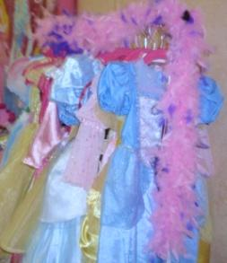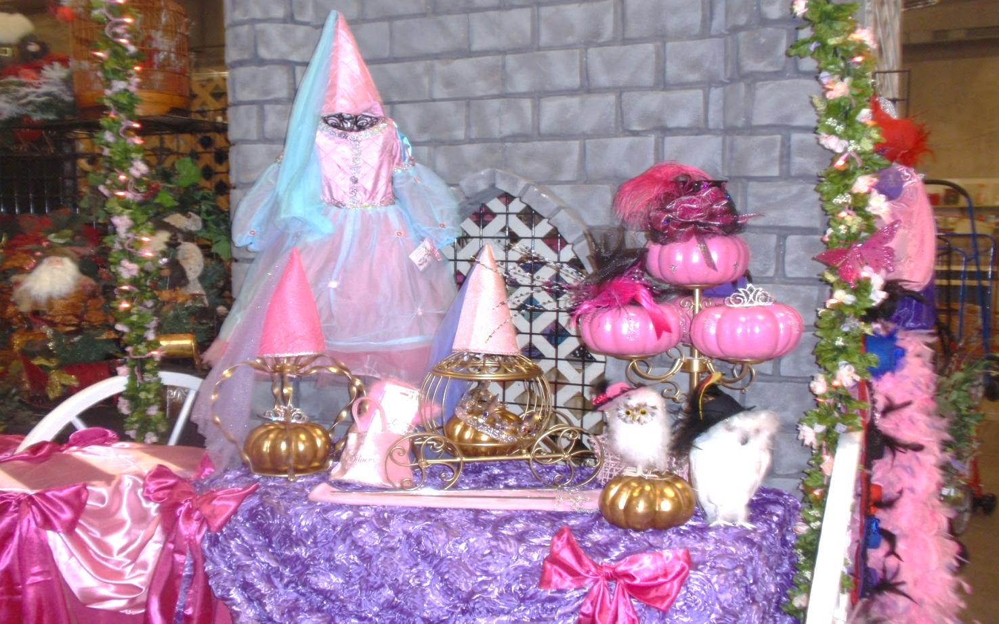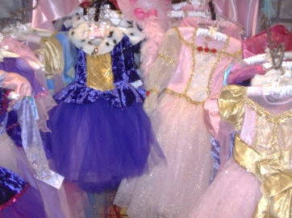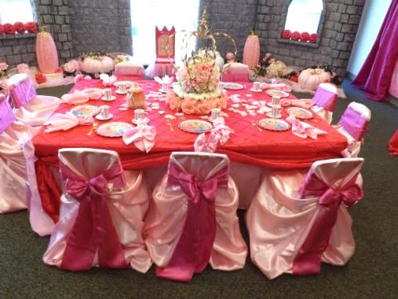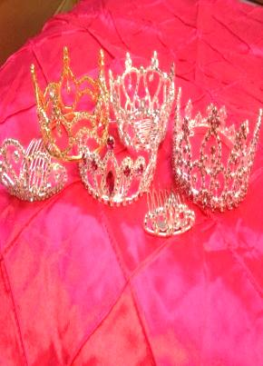

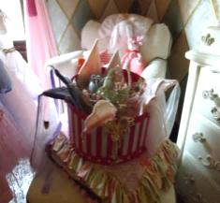

* **Add a Special Keepsake for your Birthday Princess** - Every Princess would love to have her very own Princess Ball Gown or Rhinestone Tiara to keep and cherish for years to come.

Preferred Vendors:

LD’s Specialties & Gourmet Café 234 N. Mustang Road Mustang, OK  73064 Phone: (405) 376-7277

([www.lds-specialties.com](http://www.lds-specialties.com))

Mustang Conference Center - Banquet Rooms and Rental Spaces 1201 N. Mustang Road, Mustang, OK 73064 Phone: (405) 376-3411 ([www.cityofmustang.org/departments/parks-recreation/conference-center](http://www.cityofmustang.org/departments/parks-recreation/conference-center))

Additional Affordable Elegance PackagesThemes to Choose From:

Affordable Elegance Princess Tea Party can be customize by choosing your favorite princess color scheme.

Princess Tea Party

Cinderella Tea Party

Sofia Tea Party

Rapunzel Tea Party

Frozen (Elsa & Anna) Party

Little Mermaid Tea Party

Victorian Tea Social

Mad Hatter Tea Party

Sassy Diva Tea Party

Monster Tea Party

Ooh la la Paris Tea Party

Fancy Nancy Tea Party

“Add on Party Perfections”

Set-Up and Takedown Add on Option for Affordable Elegance Decorations:

No need to worry about decorating, we‘ll do it all for you. All you have to do is come and enjoy the party.

Mad Hatter Par-Teas will come in and set up our decorations for you. We need least 2 hours before the party starts and 1 hour after it ends.

Set-up and Takedown Fee for Affordable Elegance Themes 150 and up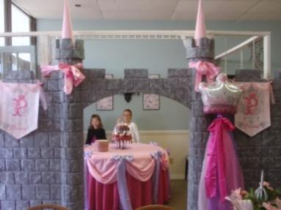

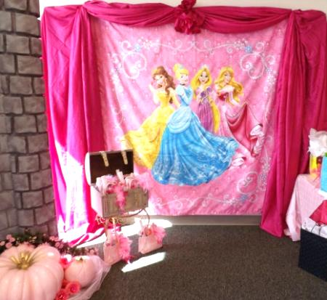

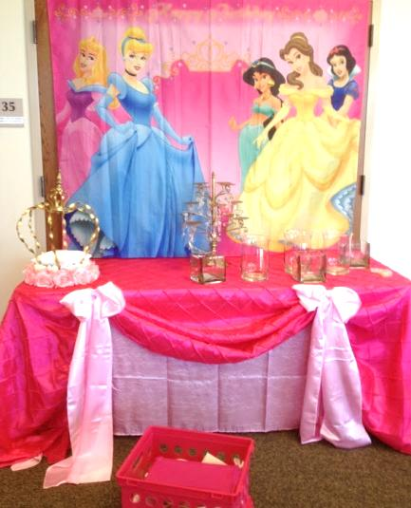

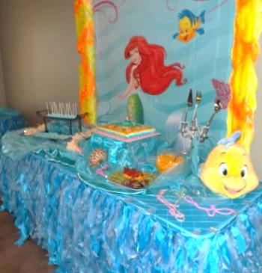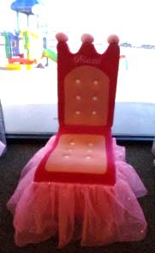

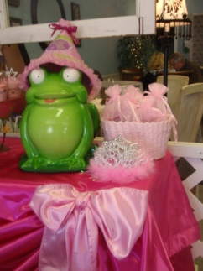

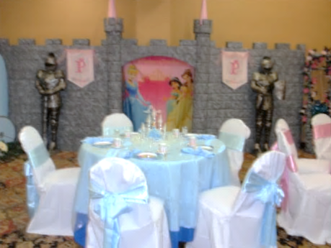

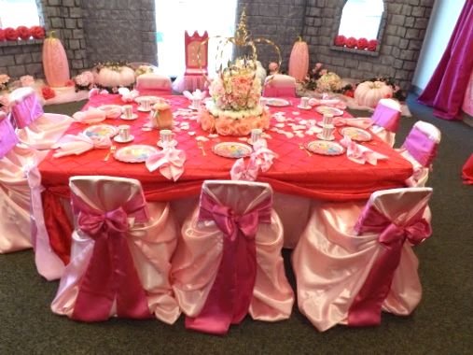

We are happy to answer any questions you might have and assist you in any way we can!!

Let us know if we need to reserve your date … We’d love to get started on your fairy-tale celebration!

For more information or to schedule a party

Contact: Thelma Logan (405) 641-0086 or email:

[madhatterpar-teas@att.net](mailto:madhatterpar-teas@att.net)

To see [more princess photos](http://mad-hatter-parties.com/princess-photos.php) visit us on our web site [www.mad-hatter-parties.com](http://www.mad-hatter-parties.com) or [facebook](https://www.facebook.com/pages/Mad-Hatter-Par-Teas/102454166480538)

