C:\Users\Thelma\AppData\Local\Microsoft\Windows\Temporary Internet Files\Content.IE5\O3RKB12M\MC900022825[1].wmfC:\Users\Thelma\AppData\Local\Microsoft\Windows\Temporary Internet Files\Content.IE5\O3RKB12M\MC900022825[1].wmf **Affordable Elegance**

Princess Dress-Up Tea Party

Princess Dress-up Tea Party (minimum of 10 of guests)

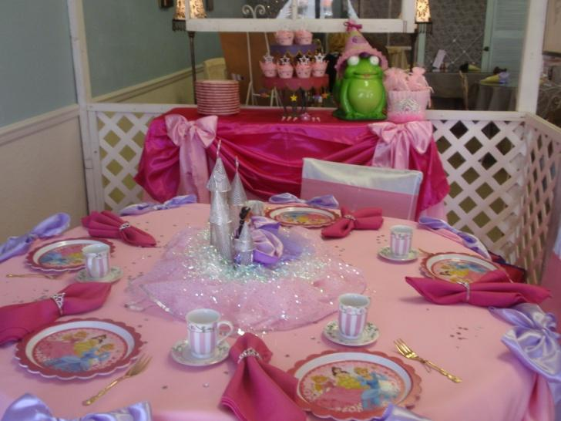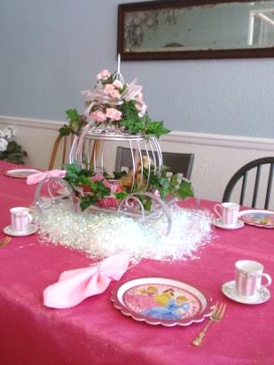This all-out party is designed for you to decorate and host yourself by providing all the magical fairy-tale décor of Mad Hatter Par-Teas to you in your own castle while your princess and her court have a magical fairy-tale celebration they will never forget!!

**Princess Tea Social Décor**

Linen for Princess Court Guest Table

Linen Overlay

Satin Bows

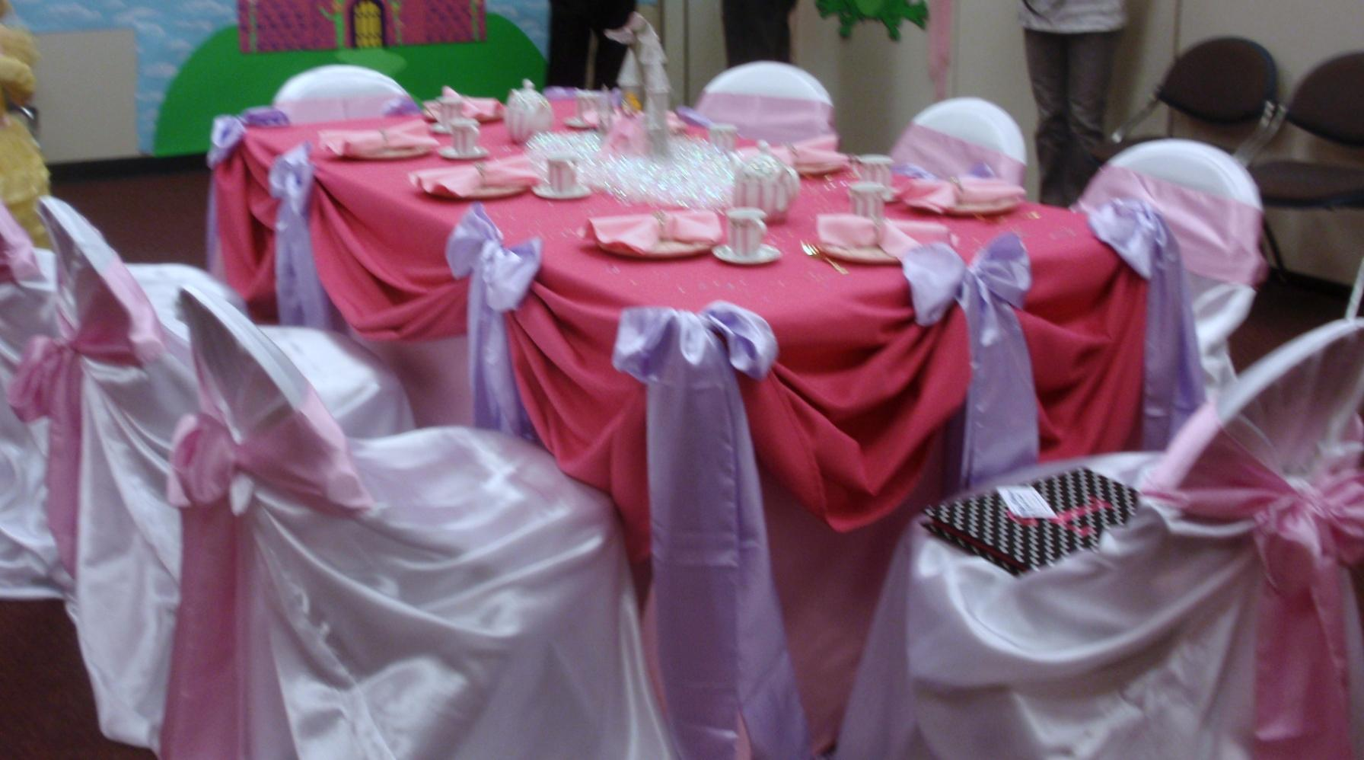Princess Centerpiece

**Princess Tea Party Setting**

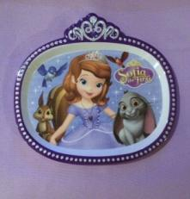Princess Plates

Child Size Tea Cups

Princess Napkins Rings

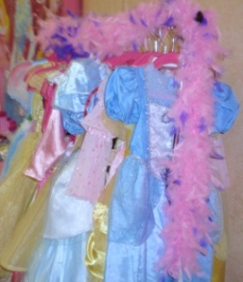Princess Forks

Linen Napkins

Princess Teapot

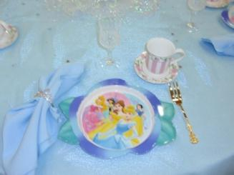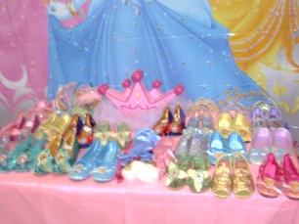**Princess Dress-up at its Finest**

(Princess dress up to wear during the party)

PrincessBall Gowns

Renaissance Hats, Tiaras, or **Enchanting** Circlets

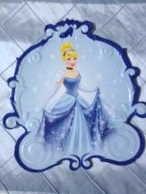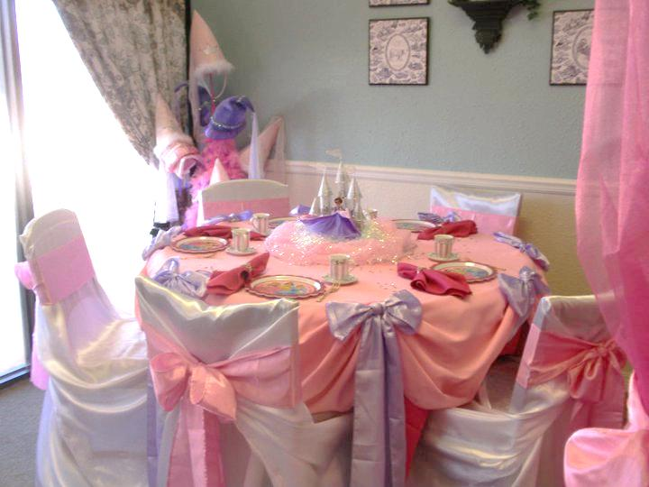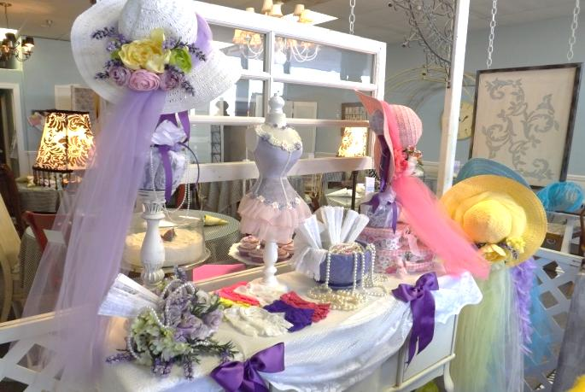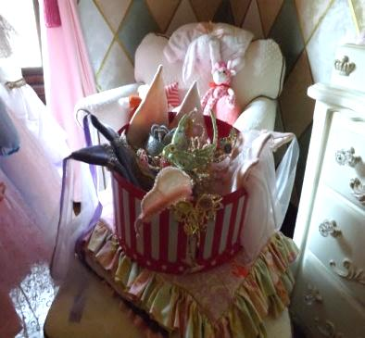Princess Faux Fur Stole or Feather Boas

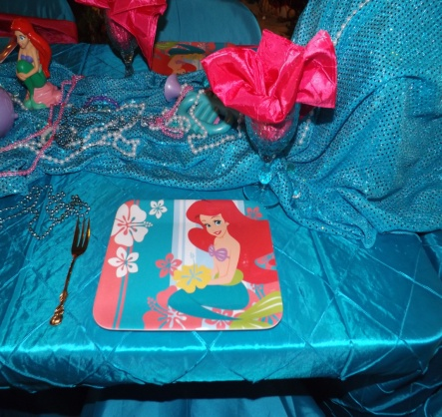Satin or Lace Gloves

PrincessShoes

Jewels & Accessories

**Princess Tea Social Activity**

Princess Dress-up Fashion Show

Princess Tea (Strawberry Lemonade or Punch)

**Princess Tea Party Thank You Favors**

Princess and her court will receive Bead Necklaces.

**All Affordable Elegance Dress-up Packages are $25 per Guests (minimum of 10 of guests)**

**Make it a Fairy-Tale Tea Party by adding the Princess Castle Prop for $150 more**

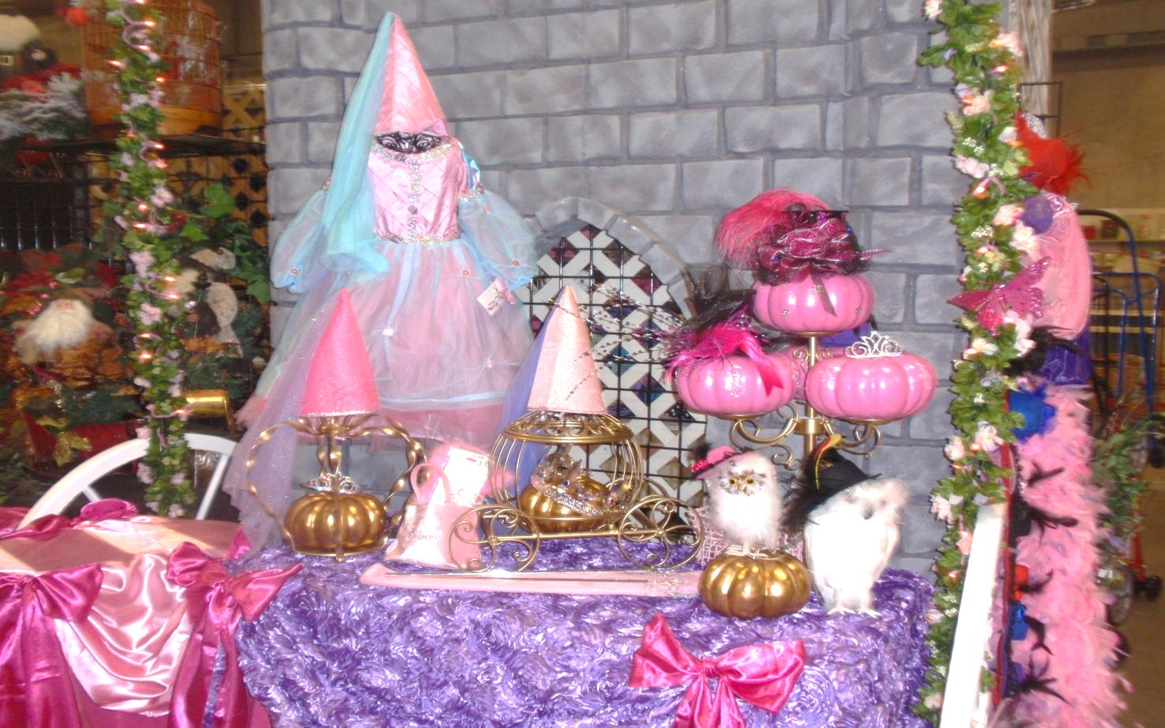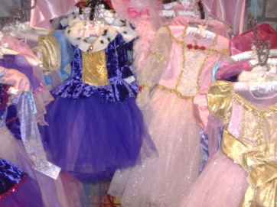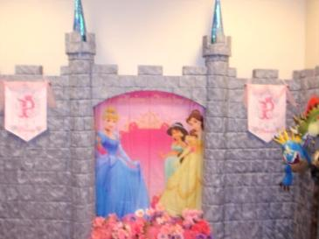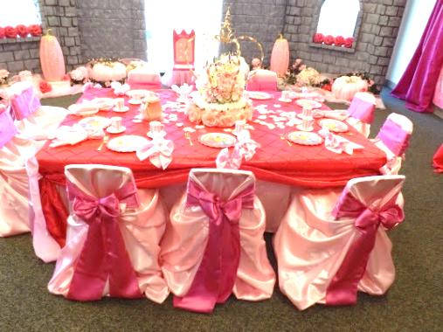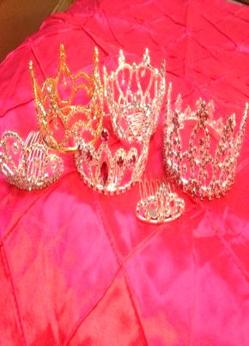

**Make it even more special by adding Chair Covers & Bows for $4 ea**

**Add a Special Keepsake for your Birthday Princess** - Every Princess would love to have her very own Princess Ball Gown or Rhinestone Tiara to keep and cherish for years to come.

**Delivery and Pick-up Fee**: No Deliveryfee if your party location is inside Mustang School District. A Deliveryfee of $35.00 will be added to the final balance if your party location is outside Mustang School District and in the Oklahoma City area. A Deliveryfee of .65 cents per mile will be added to the final balance if your party location is outside Oklahoma City, Okla. Mileage will be determined via Map Quest [www.mapquest.com](http://www.mapquest.com)

Set-Up and Takedown Affordable Elegance Decorations:

No need to worry about decorating, we‘ll do it all for you. All you have to do is come and enjoy the party.

Mad Hatter Par-Teas will come in and set up our decorations for you. We need least 2 hours before the party starts and 1 hour after it ends.

Set-up and Takedown Fee for Affordable Elegance Themes 150 and up

Preferred Vendors:

LD’s Specialties & Gourmet Café 234 N. Mustang Road Mustang, OK  73064 Phone: (405) 376-7277

([www.lds-specialties.com](http://www.lds-specialties.com))

Mustang Conference Center - Banquet Rooms and Rental Spaces 1201 N. Mustang Road, Mustang, OK 73064 Phone: (405) 376-3411 ([www.cityofmustang.org/departments/parks-recreation/conference-center](http://www.cityofmustang.org/departments/parks-recreation/conference-center))

Additional Affordable Elegance PackagesThemes to Choose From:

Affordable Elegance Princess Tea Party can be customize by choosing your favorite princess color scheme.

Princess Tea Party

Cinderella Tea Party

Sofia Tea Party

Rapunzel Tea Party

Little Mermaid Tea Party

Victorian Tea Social

Mad Hatter Tea Party

Sassy Diva Tea Party

Monster Tea Party

Ooh la la Paris Tea Party

Fancy Nancy Tea Party

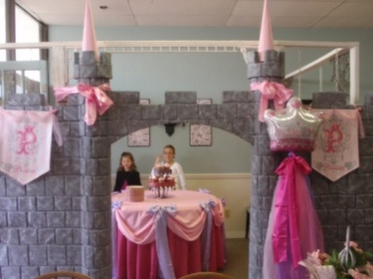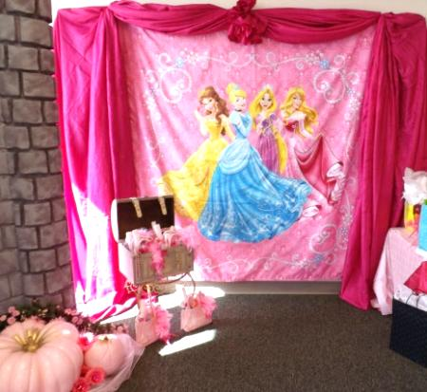Don’t forget to check out our “Add on Party Perfections”

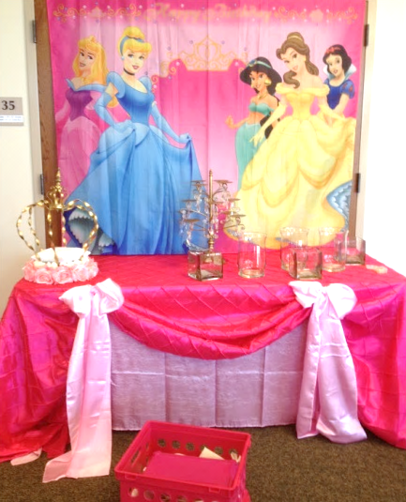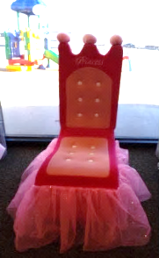

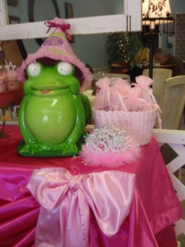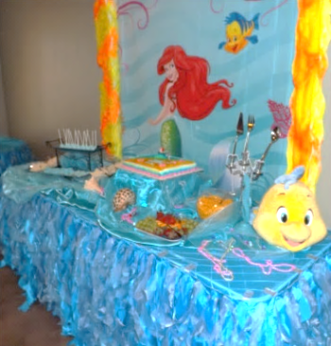

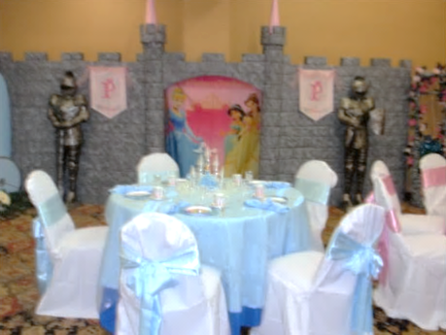

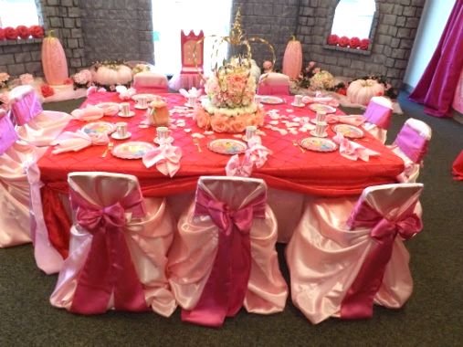

We are happy to answer any questions you might have and assist you in any way we can!!

Let us know if we need to reserve your date … We’d love to get started on your fairy-tale celebration!

For more information or to schedule a party

Contact: Thelma Logan (405) 641-0086 or email:

[madhatterpar-teas@att.net](mailto:madhatterpar-teas@att.net)

To see [more princess photos](http://mad-hatter-parties.com/princess-photos.php) visit us on our web site [www.mad-hatter-parties.com](http://www.mad-hatter-parties.com) or [facebook](https://www.facebook.com/pages/Mad-Hatter-Par-Teas/102454166480538)

