Affordable Elegance
Sassy Diva Tea Party

Affordable Elegance Sassy Diva Tea Party (minimum of 10 guests)
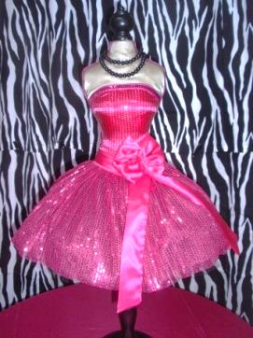
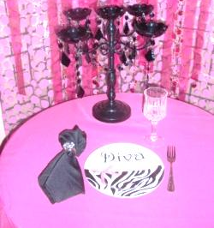
This all-out party is designed for you to decorate yourself but adding the dazzling of Mad Hatter Par-Teas décor by bringing all of the dazzling decorations to you!
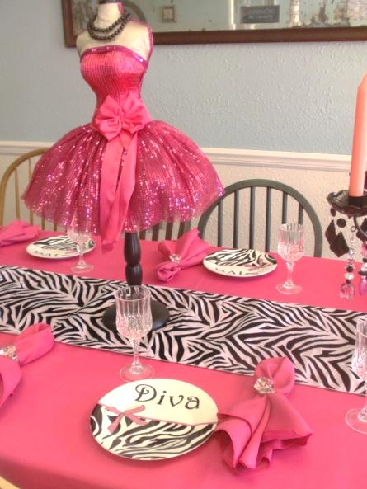
Sassy Diva Decor
Sassy Diva Zebra Backdrop
Sassy Diva Party Table Decor
Sassy Diva Party Gift Table Decor
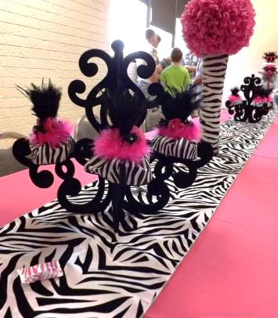
Hot Pink Table Linens
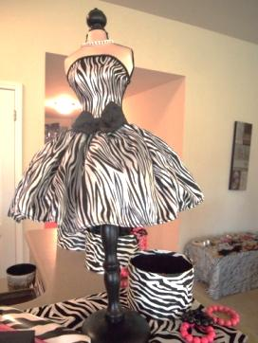
Zebra Overlay Linen
Sassy Diva Centerpiece
Sassy Diva Place Setting
Linen Napkins & Forks
Sassy Diva Zebra Plates
Crystal Goblets or Zebra Tea Cups
Sassy Diva Tea (Strawberry Lemonade)
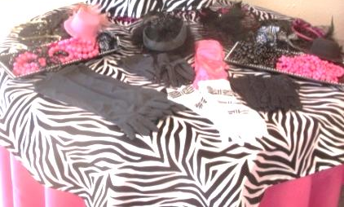
Sassy Diva Mini Dress up
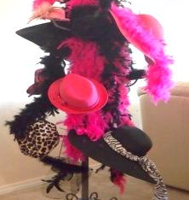
(Sassy mini dress up to wear during the party)
Fashion Hats
Faux Fur Wraps/Stoles
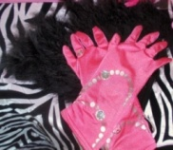
Satin Gloves
Jewels & Accessories
Mad Hatter Par-Teas’s Thank You Favor
Each guest will receive party beads

All Affordable Elegance Sassy Diva Tea Party Packages are $25 per Guests (minimum of 10 guests)

Delivery and Pick-up Fee: No Delivery fee if your party location is inside Mustang School District. A Delivery fee of $35.00 will be added to the final balance if your party location is outside Mustang School District and in the Oklahoma City area. A Delivery fee of .65 cents per mile will be added to the final balance if your party location is outside Oklahoma City, Okla. Mileage will be determined via Map Quest www.mapquest.com

Don’t forget to check out our “Add on Party Perfections”

- Make it even more sassy by adding Chair Covers & Bows for $4 ea

Additional Affordable Elegance Packages Themes to Choose From:
Affordable Elegance Tea Party can be customized by choosing your favorite color scheme.

Mad Hatter Tea Party
"Wicked"
Rock Star Dress-Up
Hollywood Dress-Up
Monster Tea Party
Ooh la la Paris Tea Party
Fancy Nancy Tea Party
Victorian Tea Social
Princess Tea Party
Cinderella Tea Party
Sofia Tea Party
Rapunzel Tea Party
Frozen (Elsa & Anna) Party
Little Mermaid Tea Party

“Add on Party Perfections”

Set-Up and Takedown Add on Option for Affordable Elegance Decorations:
No need to worry about decorating, we‘ll do it all for you. All you have to do is come and enjoy the party.
Mad Hatter Par-Teas will come in and set up our decorations for you. We need least 2 hours before the party starts and 1 hour after it ends.
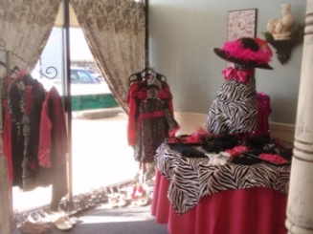
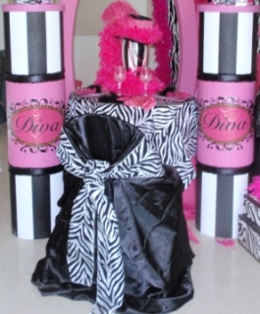
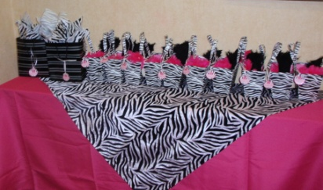
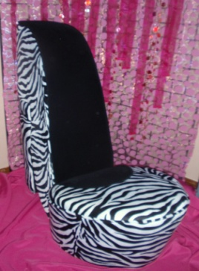
Set-up and Takedown Fee for Affordable Elegance Themes 150 and up

Preferred Vendors:
LD’s Specialties & Gourmet Café 234 N. Mustang Road Mustang, OK 73064 Phone: (405) 376-7277
(www.lds-specialties.com)

Mustang Conference Center - Banquet Rooms and Rental Spaces 1201 N. Mustang Road, Mustang, OK 73064 Phone: (405) 376-3411 (www.cityofmustang.org/departments/parks-recreation/conference-center)

We are happy to answer any questions you might have and assist you in any way we can!!

Let us know if we need to reserve your date … We’d love to get started on your celebration!

For more information or to schedule a party
Contact: Thelma Logan (405) 641-0086 or email:
madhatterpar-teas@att.net
To see more princess photos visit us on our web site www.mad-hatter-parties.com or facebook
