C:\Users\Thelma\AppData\Local\Microsoft\Windows\Temporary Internet Files\Content.IE5\W713TT9N\MC900446228[1].wmfC:\Users\Thelma\AppData\Local\Microsoft\Windows\Temporary Internet Files\Content.IE5\W713TT9N\MC900446228[1].wmfAffordable Elegance

Hollywood Bling

|  |
| --- |
| Affordable Elegance Hollywood for 10 Guests (minimum of 10 guests) |

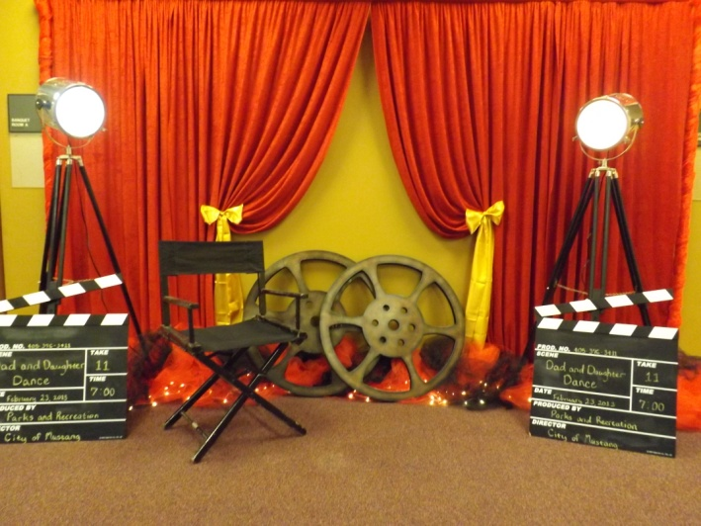This all-out party is designed for you to decorate yourself but adding the dazzling of Mad Hatter Par-Teas décor by bringing all of the dazzling decorations to you!

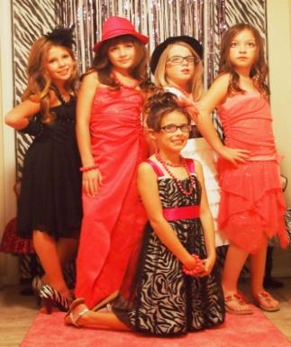***Hollywood Decor***

Red Curtain Backdrop

Red Carpet

Movie Reels

Guests Table Linens

Black Chandelier Centerpiece

***Place Setting***

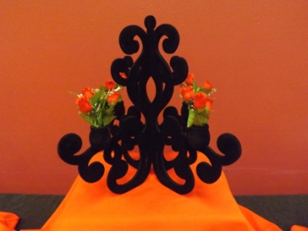Linen Napkins

Plates

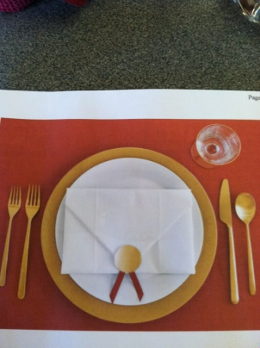Gold Chargers

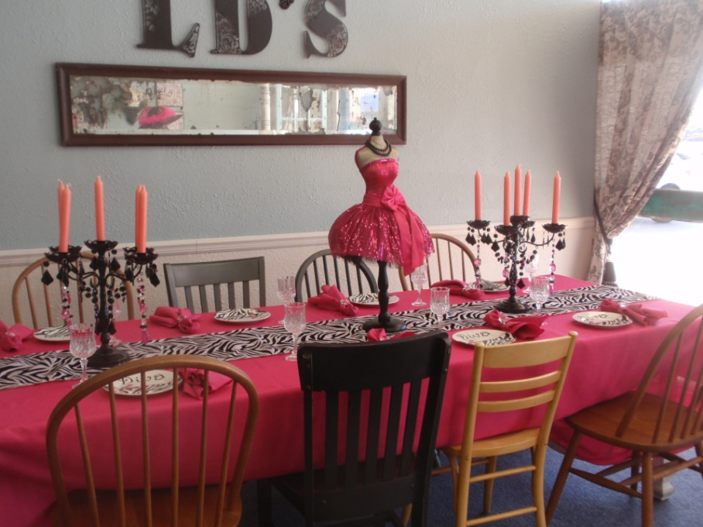Gold Forks

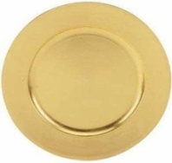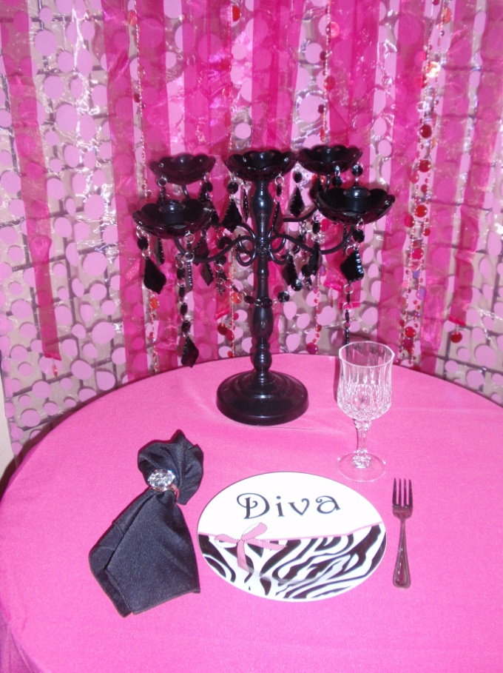Crystal Goblets

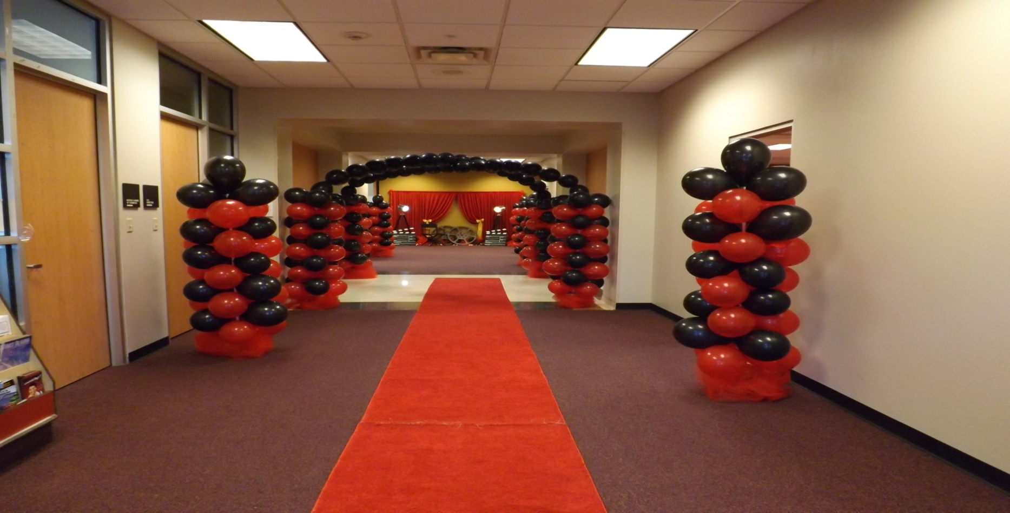***Dress-up at its Finest***

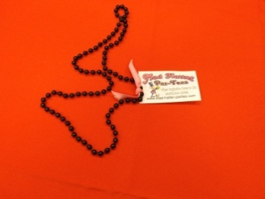Glamour Fashion Dresses

Fashion Hats

Gloves

Bling Accessories

Necklaces

Faux Wraps/Stoles or Feather Boas

***Mad Hatter Par-Teas’s Thank You Favor***

Each guestwill receive partybeads

**All Affordable Elegance Hollywood Bling Tea Party Packages are $25 per Guests (minimum of 10 guests)**

**Delivery and Pick-up Fee**: No Deliveryfee if your party location is inside Mustang or Yukon School District. A Deliveryfee of $35.00 will be added to the final balance if your party location is outside Mustang or Yukon School District and in the Oklahoma City area. A Deliveryfee of .65 cents per mile will be added to the final balance if your party location is outside Oklahoma City, Okla. Mileage will be determined via Map Quest [www.mapquest.com](http://www.mapquest.com)

**Don’t forget to check out our “Add on Party Perfections”**

* Make it even more sparkle by adding Chair Covers & Bows for $4 ea

|  |
| --- |
| Additional Affordable Elegance PackagesThemes to Choose From: |

Affordable Elegance Tea Party can be customized by choosing your favorite color scheme.

Mad Hatter Tea Party

"Wicked"

Rock Star Dress-Up

Hollywood Bling

Monster Tea Party

Ooh la la Paris Tea Party

Fancy Nancy Tea Party

Victorian Tea Social

Princess Tea Party

Cinderella Tea Party

Sofia Tea Party

Rapunzel Tea Party

Frozen (Elsa & Anna) Party

Little Mermaid Tea Party

We are happy to answer any questions you might have and assist you in any way we can!!

Let us know if we need to reserve your date … We’d love to get started on your celebration!

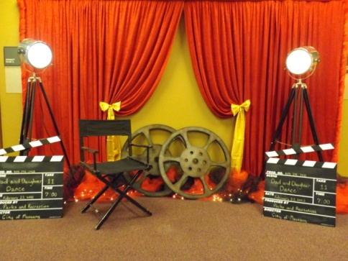**Enrich the festivity by adding on… Party Perfections:**

|  |
| --- |
| Set-Up and Takedown Decorations: |

No need to worry about decorating, we‘ll do it all for you. All you have to do is come and enjoy the party.

Mad Hatter Par-Teas will come in and set up our decorations for you. We need least 3 hours before the party starts and 1 hour after it ends.

Set-up and Takedown 150 and up

|  |
| --- |
| Hosted Party: |

Hostess will assist guests with dress up, light makeup, fashion show and gifts.

Party Hostess 25 per hour

(Hostess will assist with dress up and mini make overs - minimum of 2 hour) up to 10

One Party Server 25 per hour

(Server will serve Sandwiches & Tea - minimum of 2 hour) up to 10 guests

|  |
| --- |
| Hollywood Décor Rentals: |

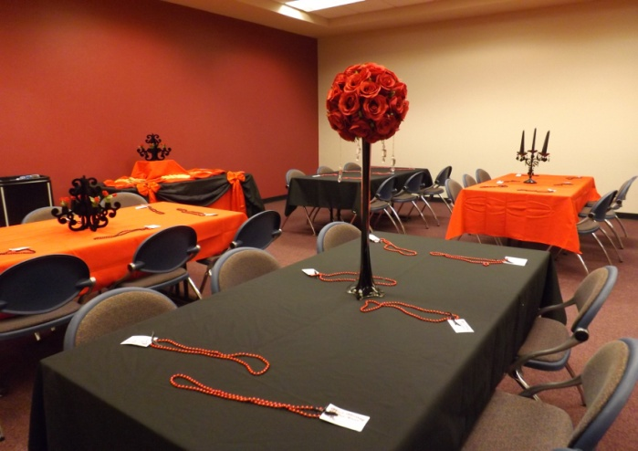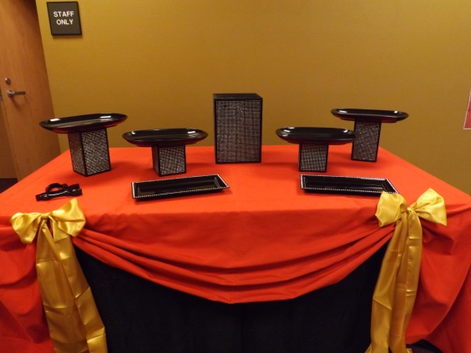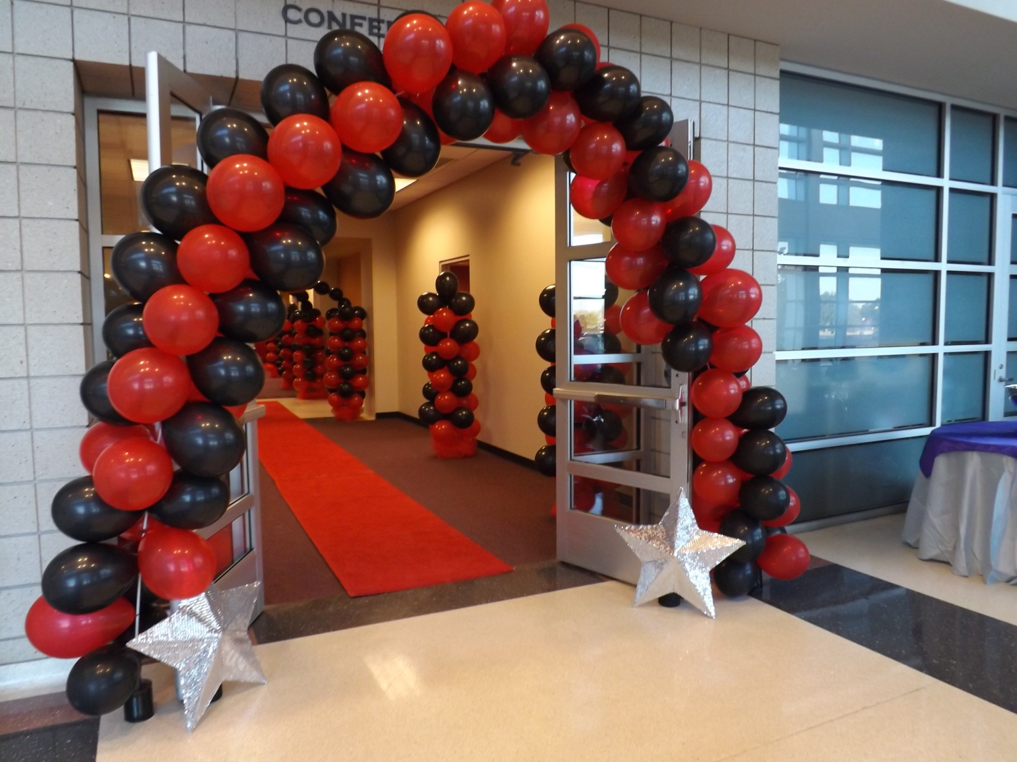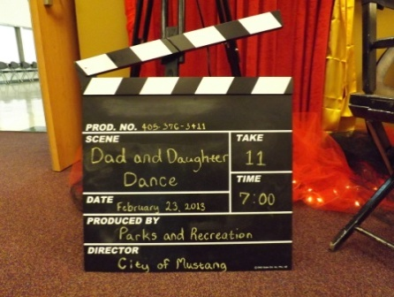

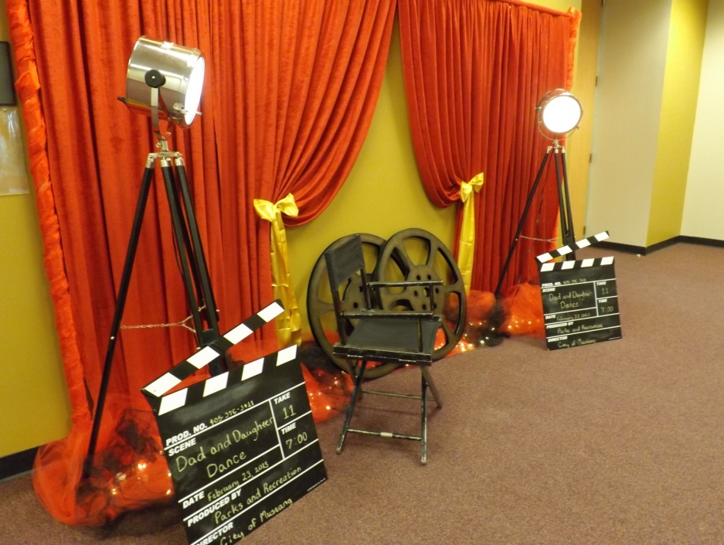

Red Curtain Backdrop (8’ x 10’ pipe and drape) 100

Red Carpet Runner 40

Movie Spot Lights 50 ea

Clap Boards 20 ea

Large Movie Reels 10 ea

Director Chair 15

Double Sided Gold/ Pink Arch 30

Black Chandelier 15

Black Velvet Chandelier 10

Bling Raisers with Black Platters 20

2’ Silver Stars 10 ea

Additional Centerpiece (Small) Rental 5 ea

Additional Centerpiece (Med) Rental 10 ea

Additional Centerpiece (Large) Rental 20 ea

Additional Centerpiece (X Large) Rental 30 ea

|  |
| --- |
| Table Décor Rentals: |

Food/Cake Table Linen & Overlays 30 ea and up

Gift Table Linen & Overlay 20 ea

Welcome Table Linen & Bows 20 ea

|  |
| --- |
| Place Setting Rentals: |

Plates

Gold Charger

Goblets

Forks

Linen Napkins

Napkins Rinks

Place Setting Rental 5 ea

|  |
| --- |
| Hollywood Dress **-** Up at its Finest Rentals: |

(Dress up in the latest and fun fashion trends & accessories to wear during the party)

Glamour Fashion Dresses

Fashion Hats

Gloves

Bling Accessories

Necklaces

Faux Wraps/Stoles or Feather Boas

Dress - Up Rental 15 - 25 ea

|  |
| --- |
| Mini Dress-Up Rentals: |

(Mini dress up to wear during the party)

Fashion Hats

Faux Fur Wraps/Stoles

Satin Gloves

Jewels & Accessories

Sassy Mini Dress Up Rental 5 - 10 ea

|  |
| --- |
| Mini Make Over: |

Light Make up for Divas

Make-Up Table Decor

1 - Table Linen

1 - Zebra Overlay Linen

Mini Make-Over (per guest) 10 - 15 ea

|  |
| --- |
| Fashion Décor Rentals: |

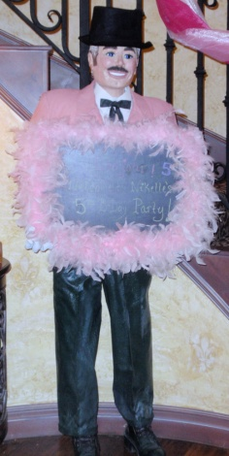Double Sided Gold/ Pink Arch 30

Purple Runway Carpet Runner 35

Pink Runway Carpet Runner 30

Male Butler with Message Board 40

Diva Décor Tubes 20

Glamour Décor Tubes 20

Large Diva Zebra Chair 30

Small Diva Zebra Chair 15

Zebra Backdrop 15

Hot Pink or Purple Floor Mirror 20

|  |
| --- |
| Mini Spa Rentals: |

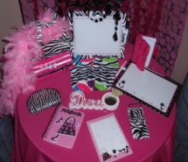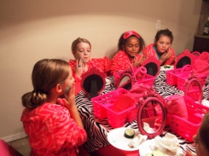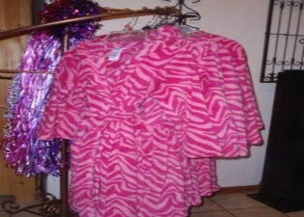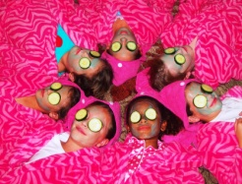(Dress up in the latest and fun sassy spa fashion trends to wear during the party)

Fun 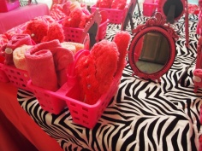Sassy Pink Zebra Robes

Towel Head Wraps

Pink Wash Cloths

Mirror

Mini Spa 15 ea

|  |
| --- |
| Hollywood Favors: |

Favor Bags or Favors (per guest) 5 to 20 ea

Thank You Gift (per guest) 5 to 20 ea

Personal Water Bottle, Candy Wrappers or Favors Labels 2 ea

Professional Face Painting (minimum of two hours and travel fee 15 miles outside Yukon) 75 per hour

|  |
| --- |
| Welcome Table Guest/Photo Album and Table for Gifts: |

Guests will sign their name & list the gift they brought (with help from parent or hostess if needed). This is an attractive and excellent way to have an accurate record of guests/gifts to aid you when sending thank you cards. Plus the birthday girl will have a cherished keepsake guest/photo album to remember her Birthday Bash.

1 - Guest/Photo Album Keepsake

1 - Pin

1 - 4’ Table

1 - Hot Pink Table Linen

1 - Overlay Linen

Welcome Sign in a Photo Frame

Guest/Photo Album 40

|  |
| --- |
| Additional Rentals ( added with package): |

Additional Tablecloths Zebra Overlay Square 8 - 10 ea

Additional Tablecloths Rental 8-10 ea

Additional Tablecloths Rental (Floor Length) 15 ea

Additional Tablecloth Overlays Rental 5-10 ea

Additional Specialty Tablecloth Rental 30 ea and up

Additional Chair Covers & Bows 4 ea

Additional Centerpiece (Small) Rental 5 ea

Additional Centerpiece (Med) Rental 10 ea

Additional Centerpiece (Large) Rental 20 ea

Additional Centerpiece (X Large) Rental 30 ea

Additional Tables (4’ rectangle) 7 ea

Additional Tables (48” round 6’ rec) 10 ea

Additional Chairs 2 ea

Additional Serving Platters 10 - 20 ea

3-Tier Cupcake Stand or Cupcake Stands 10 - 20 ea

White or Clear Buffet Platters 20

|  |
| --- |
| Preferred Vendors: |

LD’s Specialties & Gourmet Café 234 N. Mustang Road Mustang, OK  73064 Phone: (405) 376-7277

([www.lds-specialties.com](http://www.lds-specialties.com))

Mustang Conference Center - Banquet Rooms and Rental Spaces 1201 N. Mustang Road, Mustang, OK 73064 Phone: (405) 376-3411 ([www.cityofmustang.org/departments/parks-recreation/conference-center](http://www.cityofmustang.org/departments/parks-recreation/conference-center))

For more information or to schedule a party

Contact: Thelma Logan (405) 641-0086 or email:

[madhatterpar-teas@att.net](mailto:madhatterpar-teas@att.net)

To see [more princess photos](http://mad-hatter-parties.com/princess-photos.php) visit us on our web site [www.mad-hatter-parties.com](http://www.mad-hatter-parties.com) or [facebook](https://www.facebook.com/pages/Mad-Hatter-Par-Teas/102454166480538)