Enrich the festivity by adding on… Party Perfections for Diva:
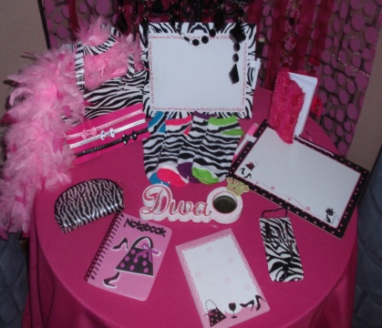
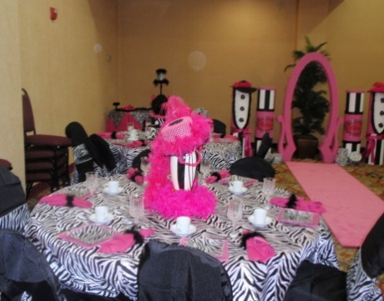
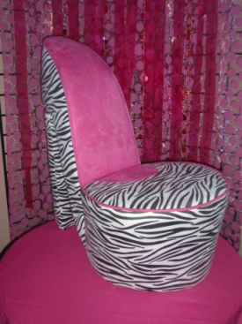
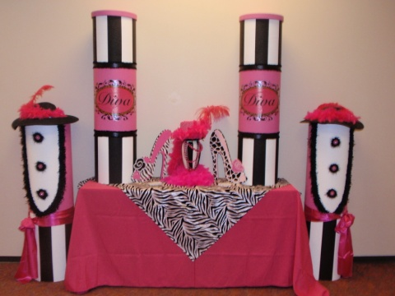
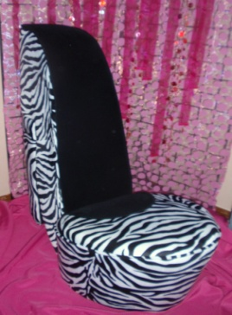

Set-Up and Takedown Royal Decorations:
No need to worry about decorating, we‘ll do it all for you. All you have to do is come and enjoy the party.
Mad Hatter Par-Teas will come in and set up our decorations for you. We need least 2 hours before the party starts and 1 hour after it ends.
Set-up and Takedown Fee 150 and up

Hosted Party:
One Party Hostess Fee 25 per hour
(Hostess will assist with games - minimum of 2 hour) up to 12

One Party Server Fee 25 per hour
(Server will serve Sassy Sandwiches & Sassy Tea - minimum of 2 hour) up to 12 guests

Sassy Place Setting Rentals:
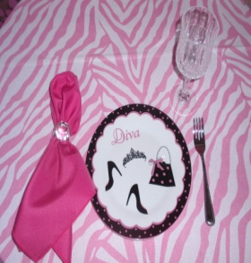
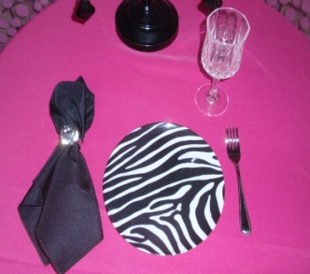
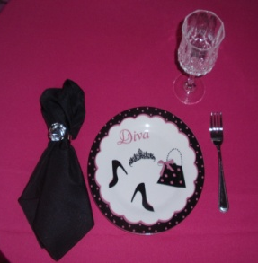
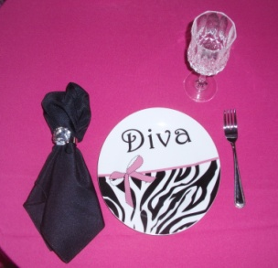
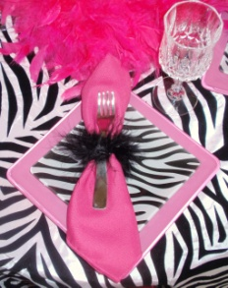
Diva Zebra Plates
Zebra Dessert Plates
Pink Plates
Goblets or Zebra Tea Cups
Forks
Linen Napkins
Napkins Rinks
Sassy Place Setting Rental 5 ea

Sassy Diva Dress - Up Rentals:
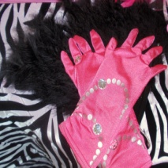
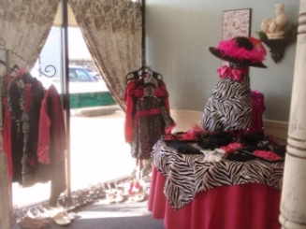
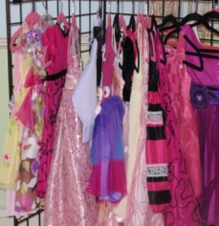
(Dress up in the latest and fun fashion trends & accessories to wear during the party)
Fun Fashion Dresses
Fashion Hats
Gloves
Accessories
Necklaces
Faux Wraps/Stoles or Feather Boas
Dress - Up Rental 15 ea

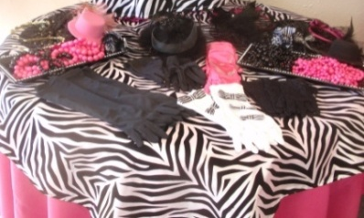
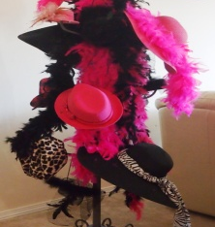
Sassy Diva Mini Dress-Up Rentals:
(Sassy mini dress up to wear during the party)
Fashion Hats
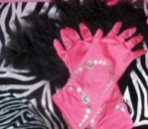
Faux Fur Wraps/Stoles
Satin Gloves
Jewels & Accessories
Sassy Mini Dress Up Rental 7 ea

Sassy Diva Mini Make Over:
Light Make up for Divas
Make-Up Table Decor
1 – Hot Pink Table Linen
1 – Zebra Overlay Linen
Mini Make-Over (per guest) 10 ea

Mini Spa Rentals:
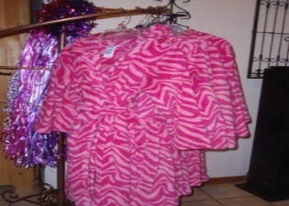
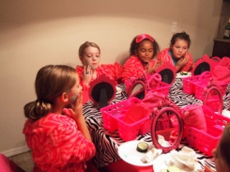
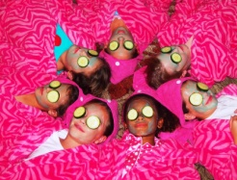
(Dress up in the latest and fun sassy spa fashion trends to wear during the party)
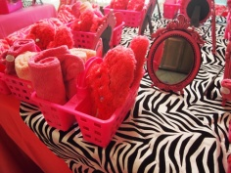
Fun Sassy Pink Zebra Robes
Towel Head Wraps
Pink Wash Cloths
Mirror
Mini Spa 15 ea

Sassy Diva Fashion Décor Rentals:
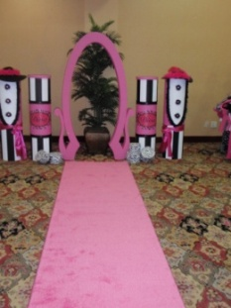
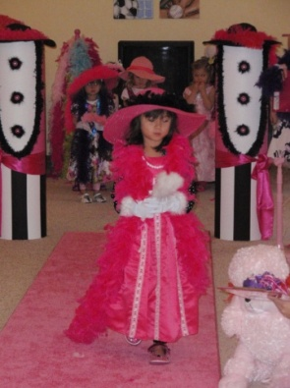
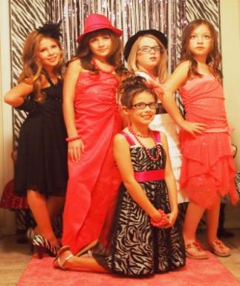

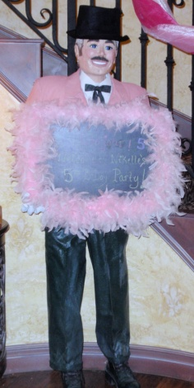
Diva Arch 35
Pink Runway Carpet Runner 25
Male Butler with Message Board 35
Sassy Diva Décor Tubes 20
Glamour Décor Tubes 20
Large Diva Zebra Chair 35
Small Diva Zebra Chair 15
Zebra Backdrop 15
Black Chandelier 10
Hot Pink or Purple Floor Mirror 20

Sassy Diva Favors and Activities:
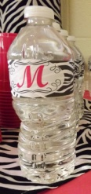
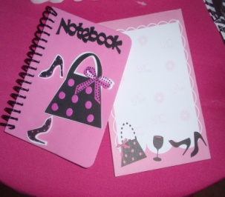
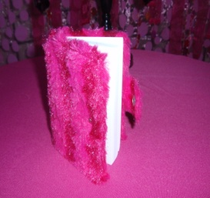
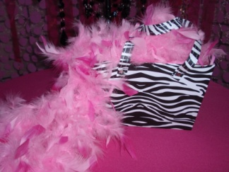
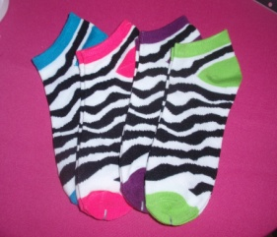
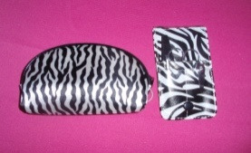
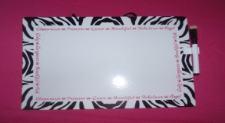
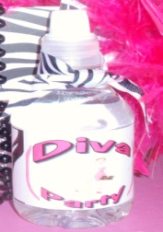

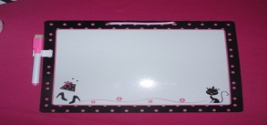
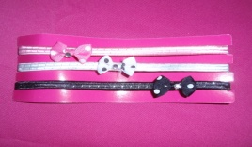

Diva Favor Bags or Favors (per guest) 5 to 20 ea
Thank You Gift (per guest) 5 to 20 ea
Personal Water Bottle, Candy Wrappers or Favors Labels 2 ea
Candy Buffet Bar 6 ea
Sassy Treasure Hunt- Each guest receive a favor 10 ea
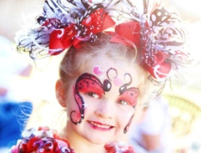
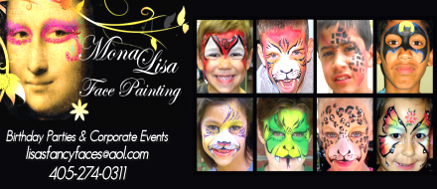
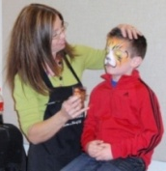
Mona Lisa Face Painting (minimum of two hours call Lisa for details and scheduling) 405 274-0311
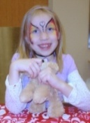

Sassy Diva Welcome Table Guest/Photo Album and Table for Gifts:
Guests will sign their name & list the gift they brought (with help from parent or hostess if needed). This is an attractive and excellent way to have an accurate record of guests/gifts to aid you when sending thank you cards. Plus the birthday girl will have a cherished keepsake guest/photo album to remember her diva fashion show.
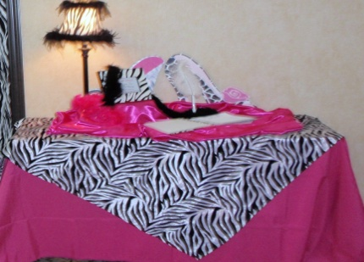
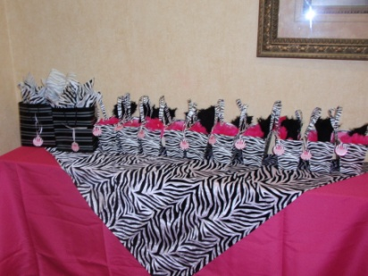
1 – Zebra Guest/Photo Album Birthday Diva Keepsake
1 – Sassy Pin
1 – 4’ Table
1 – Hot Pink Table Linen
1 – Zebra Overlay Linen
Welcome Sign in a Zebra Photo Frame

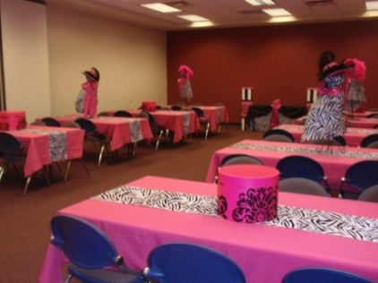
Decorated Sassy Welcome Table with Guest/Photo Album Keepsake 40
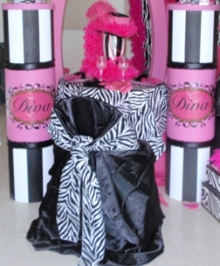

Table Décor Rentals:
Food/Cake Table Linen & Overlay 30 ea and up
Gift Table Linen & Overlay 20 ea
Welcome Table Linen & Overlay 20 ea

Additional Rentals:
Additional Tablecloths Zebra Overlay Square 8 - 10 ea
Additional Tablecloths Rental 8-10 ea
Additional Tablecloths Rental (Floor Length) 15 ea
Additional Tablecloth Overlays Rental 5-10 ea
Additional Specialty Tablecloth Rental 30 ea and up
Additional Chair Covers & Bows 4 ea
Additional Centerpiece (Small) Rental 5 ea
Additional Centerpiece (Med) Rental 10 ea
Additional Centerpiece (Large) Rental 20 ea
Additional Centerpiece (X Large) Rental 30 ea
Additional Tables (4’ rectangle) 7 ea
Additional Tables (48” round 6’ rec) 10 ea
Additional Chairs 2 ea
Child Size Table with Four Chairs 15
Additional Serving Platters 10 - 20 ea
3-Tier Cupcake Stand or Cupcake Stands 10 - 20 ea
White or Aqua Buffet Platters 15

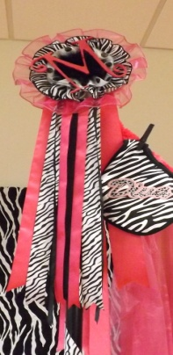
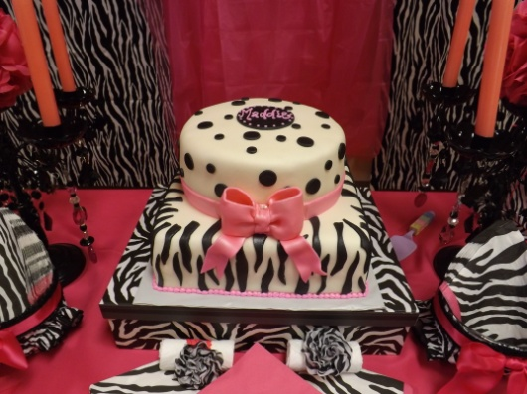
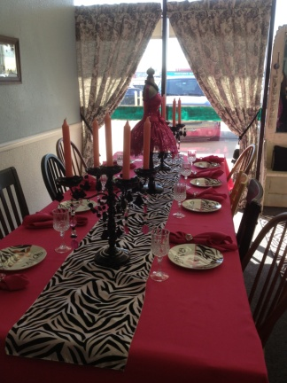
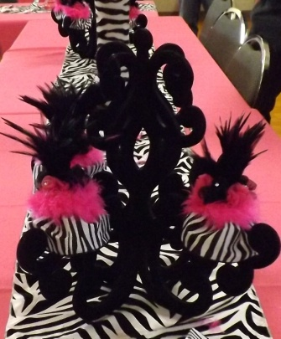
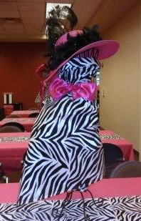

Sassy Tea Cuisine:
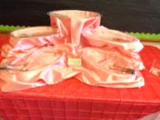
Heart Shape Tea Sandwiches with Princess Serving Platters
Assorted Seasonal Fruit and Cheese
Sassy Tea (Strawberry Lemonade)
Sassy Tea Cuisine (Serves 16-20 guests) 75

Additional Sassy Cuisine:
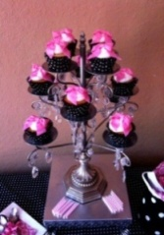
Sassy Cupcakes with 3-Tier Cupcake Stand or Princess Cupcake Stand 25 and up doz
Sassy Princess Two Layer Cake with Cake Stand .Varies
Sassy Candy Buffet Bar 6 ea
Sassy Water Bottle, Candy Wrappers or Favors Labels 2 ea
Parents Assorted Drinks or Bottle Water with Mix favors Packets 2 ea
Parents Platter with Serving Platters (Assorted Sandwiches Serves 12-16) 40

Preferred Vendors:

LD’s Specialties & Gourmet Café 234 N. Mustang Road Mustang, OK 73064 Phone: (405) 376-7277
(www.lds-specialties.com)

Mustang Conference Center - Banquet Rooms and Rental Spaces 1201 N. Mustang Road, Mustang, OK 73064 Phone: (405) 376-3411 (www.cityofmustang.org/departments/parks-recreation/conference-center)

For more information or to schedule a party
Contact: Thelma Logan (405) 641-0086 or email:
madhatterpar-teas@att.net
To see more princess photos visit us on our web site www.mad-hatter-parties.com or facebook

